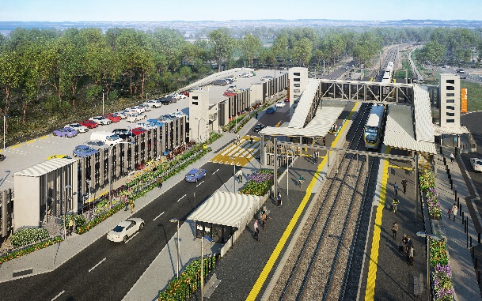
Dakabin station accessibility upgrade

WORKS NOTICE

Temporary road closure – Thompson Road, Dakabin
Monday 28 September 2020 to mid-2021

To enable the safe construction of the Dakabin station accessibility upgrade and multi-storey carpark, Queensland Rail will temporarily close Thompson Road to vehicles through the station precinct for up to nine months, from Monday 28 September 2020 until mid-2021 (site conditions permitting).
During this time, traffic management will be in place to direct road users and pedestrians around the closure. Vehicle turnaround facilities will be provided on Thompson Road at each end of the closure.
The alternative route for through traffic will be via Ann Street, Marsden Road and Alma Road (see map over the page). Motorists are advised to drive to the changed conditions and follow the instructions of the traffic controllers. Access to private properties will be maintained.
Safe north-south pedestrian access will be maintained. The lit path through Bob Brock Park will provide a pedestrian connection with Marsden Road.
Customer access to Dakabin station will be maintained during the road closure and the station will continue to operate throughout construction, except during planned track closures (to be notified separately).
Temporary customer set down (kiss’n’ride) zones will operate on Narangba Road (south of the station, opposite Lakeside Road) and at each end of the Thompson Road closure (north, near Alma Road and south, near the temporary station entrance) – see map over, marked with blue diamonds.
Residents adjacent to works may experience some noise from construction activities and vehicle movements. Every effort will be made to carry out these works with minimal disruption.
This road closure will enable our contractor to deliver critical elements of the program in a safe environment, isolated from through traffic and the public. We apologise for any inconvenience and appreciate the local community’s cooperation during these important works.
Queensland Rail Limited ABN 71 132 181 090
For traffic management enquiries, please contact John Holland Group’s on-site representative on telephone 0428 051 718.
The Dakabin station accessibility upgrade is part of the State Government’s $357 million investment to upgrade stations across the South East Queensland network, making them accessible for all customers.
For more information about the accessibility upgrade, please contact the project’s community team on free call 1800 722 203 or email stationsupgrade@qr.com.au

Sign up at queenslandrail.com.au/EmailNotification or contact us if you prefer to receive paper copies.

Page 2

Thompson Road closure and alternative route
Monday 28 September 2020 to mid-2021
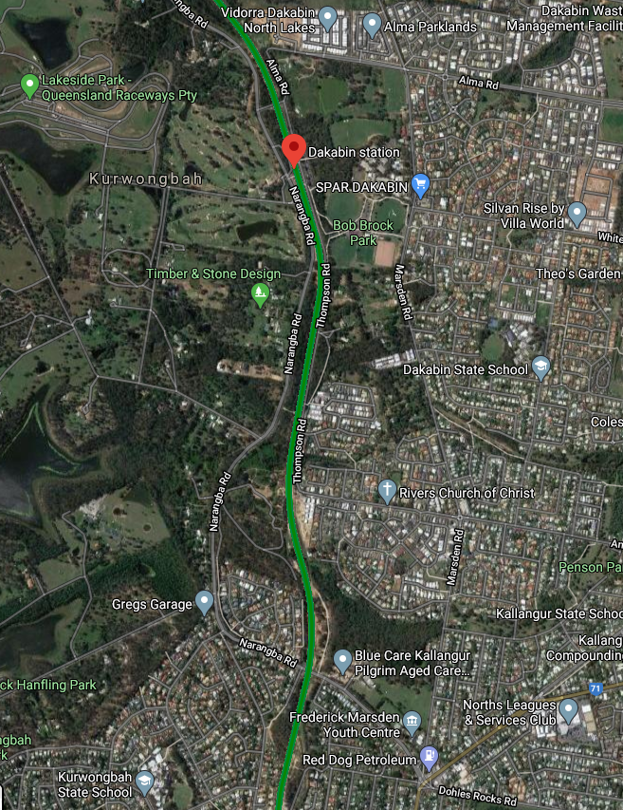

1111

1111
Thompson Road closure – 28 Sep 2020 to mid-2021
Alternative route (vehicles)
Pedestrian access maintained

Temporary passenger set down zones
Dakabin station and rail line
Map data © Google, 2020

For traffic management enquiries, please contact John Holland Group’s on-site representative on telephone 0428 051 718.
For more information about the Dakabin station accessibility upgrade, please contact the project’s community team on free call 1800 722 203 or email stationsupgrade@qr.com.au

We are moving towards paperless notifications about noise and works. You will still see paper notices as we transition to the new system. Sign up at queenslandrail.com.au/EmailNotification or contact us if you prefer to receive paper copies.

