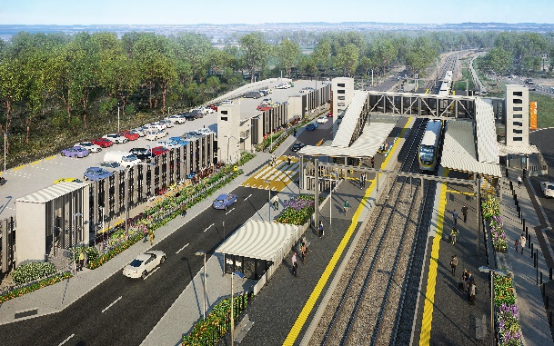
Dakabin station accessibility upgrade

WORKS NOTICE

Temporary road closure – Thompson Road, Dakabin
Extended to Thursday 30 September 2021

To enable the safe construction of the Dakabin station accessibility upgrade and multi-storey carpark, Queensland Rail has extended the current temporary closure of Thompson Road to vehicles through the station precinct until Thursday 30 September 2021 (site conditions permitting).
During this time, traffic management will be in place to direct road users and pedestrians around the closure. Vehicle turnaround facilities will be provided on Thompson Road at each end of the closure.
The alternative route for through traffic will be via Ann Street, Marsden Road and Alma Road (see map over the page). Motorists are advised to drive to the changed conditions and follow the instructions of the traffic controllers. Access to private properties will be maintained.
Safe north-south pedestrian access will be maintained. The lit path through Bob Brock Park will provide a pedestrian connection with Marsden Road.
Customer access to Dakabin station will be maintained during the road closure and the station will continue to operate throughout construction, except during planned track closures (to be notified separately).
Temporary customer set down (kiss’n’ride) zones will continue to operate on Narangba Road (south of the station, opposite Lakeside Road) and at each end of the Thompson Road closure (north, near Alma Road and south, near the temporary station entrance) – see map over, marked with blue diamonds.
Residents adjacent to works may experience some noise from construction activities and vehicle movements. Every effort will be made to carry out these works with minimal disruption.
The extension to this road closure is necessary due to adverse weather events experienced and other construction conditions encountered during these works. The closure will enable our contractor to deliver the remaining elements of the program (including completion of the multi-storey carpark) in a safe environment, isolated from through traffic and the public. We apologise for any inconvenience and appreciate the local community’s continued patience and cooperation as we build you a better Dakabin station.
Queensland Rail Limited ABN 71 132 181 090
For traffic management enquiries, please contact John Holland Group’s on-site representative on telephone 0439 186 677.
The Dakabin station accessibility upgrade is part of the State Government’s investment of more than $500 million to upgrade stations across the South East Queensland network, making them accessible for all customers.
For more information about the accessibility upgrade, please contact the project’s community team on free call 1800 722 203 or email stationsupgrade@qr.com.au

.

Page 2.

Thompson Road closure and alternative route
Extended to Thursday 30 September 2021
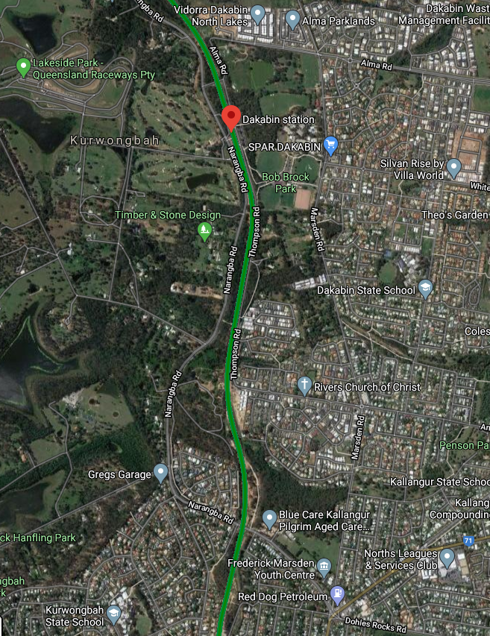

1111

1111
Thompson Road closure – extended to 30 Sep 2021
Alternative route (vehicles)
Pedestrian access maintained

Temporary passenger set down zones
Dakabin station and rail line

Map data © Google, 2021

For traffic management enquiries, please contact John Holland Group’s on-site representative on telephone 0439 186 677.
For more information about the Dakabin station accessibility upgrade, please contact the project’s community team on free call 1800 722 203 or email stationsupgrade@qr.com.au

