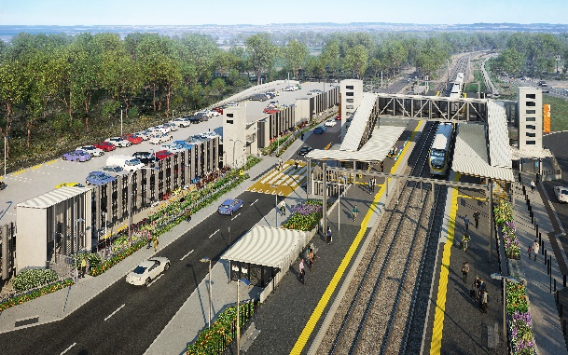
Dakabin station accessibility upgrade

WORKS NOTICE

Extension to road closure – Thompson Road, Dakabin
Extended to Tuesday 30 November 2021

To enable the completion of the Dakabin station accessibility upgrade and multi-storey carpark, the current temporary closure of Thompson Road to vehicles through the station precinct has been extended until Tuesday 30 November 2021 (weather and construction conditions permitting).
This further road closure extension is necessary due to recent adverse weather impacting the construction program.
Traffic management will continue to direct road users and pedestrians around the closure. Vehicle turnaround facilities are provided on Thompson Road at each end of the closure.
The alternative route for through traffic via Ann Street, Marsden Road and Alma Road remains in operation (see map over the page). Motorists are advised to drive to the changed conditions and follow the instructions of the traffic controllers. Access to private properties will be maintained.
Safe north-south pedestrian access will continue to be maintained. The lit path through Bob Brock Park provides a pedestrian connection with Marsden Road.
Dakabin station remains operational and customer access will be maintained during the remaining upgrade works, except during planned track closures (to be notified separately).
Temporary customer set down (kiss’n’ride) zones will continue to operate on Narangba Road (south of the station, opposite Lakeside Road) and at each end of the Thompson Road closure (north, near Alma Road and south, near the temporary station entrance) – see map over, marked with blue diamonds.
Residents adjacent to works may experience some noise from construction activities and vehicle movements. Every effort will be made to carry out these works with minimal disruption.
The road closure will provide a safe environment to enable our contractor to complete the reinstatement of Thompson Road and surrounding station infrastructure. We appreciate your continued patience and cooperation as we deliver your new Dakabin station.
Queensland Rail Limited ABN 71 132 181 090
For traffic management enquiries, please contact John Holland Group’s on-site representative on telephone 0439 457 286.
The Dakabin station accessibility upgrade is part of the State Government’s investment of more than $500 million to upgrade stations across the South East Queensland network, making them accessible for all customers.
For more information about the accessibility upgrade, please contact the project’s community team on free call 1800 722 203 or email stationsupgrade@qr.com.au

.Sign up for electronic notifications at queenslandrail.com.au/EmailNotification

Page 2.

Thompson Road closure and alternative route
Extended to Tuesday 30 November 2021
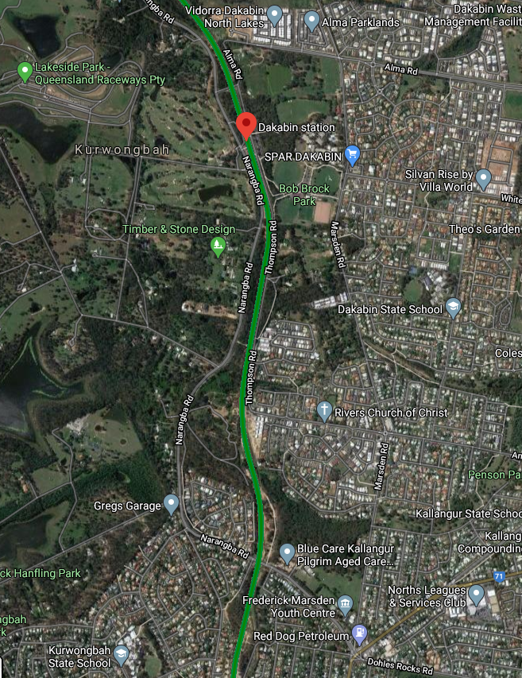

1111

1111
Thompson Road closure – extended to 30 Nov 2021
Alternative route (vehicles)
Pedestrian access maintained

Temporary passenger set down zones
Dakabin station and rail line

Map data © Google, 2021

For traffic management enquiries, please contact John Holland Group’s on-site representative on telephone 0439 457 286.
For more information about the Dakabin station accessibility upgrade, please contact the project’s community team on free call 1800 722 203 or email stationsupgrade@qr.com.au

Sign up for electronic notifications at queenslandrail.com.au/EmailNotification

