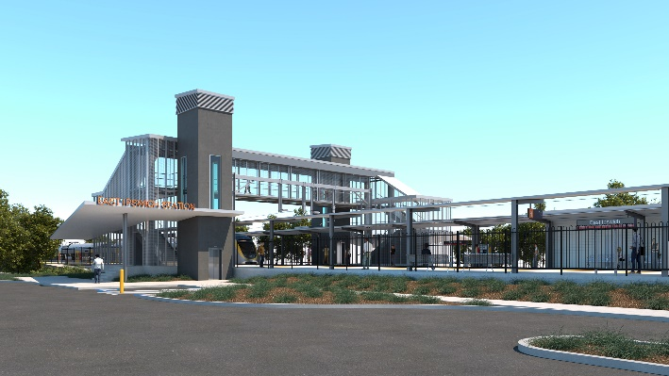
East Ipswich station accessibility upgrade

WORKS NOTICE

Night works and overhead line activities (preliminary works)

April 2020

As part of ongoing preliminary works for the East Ipswich station accessibility upgrade, Queensland Rail has scheduled night and other associated works in April 2020 (weather and construction conditions permitting).
These activities are required to prepare for works during a scheduled track closure in early May 2020 (to be notified closer to the date). Where indicated, night works can only be undertaken when there is reduced rail traffic or the overhead power is switched off.
Nearby residents may notice noise associated with construction activities in the vicinity of the station precinct and adjacent rail corridor. Every effort will be made to minimise disruption and we apologise for any inconvenience as we work to improve your station.
Overview of works
Queensland Rail Limited ABN 71 132 181 090
Location | Dates and hours of work | Type of work
East Ipswich station precinct (including carparks and rail corridor)  Rail corridor access gates:  - Irvine and Bunya Streets, East Ipswich  - Coronation and Merton Streets, East Ipswich | Set up work compound in carparks and deliveries of materials:  Between Monday 6 and Friday 10 April (daytime shifts)  Associated works (excavation):  Tuesday 7 to Friday 10 April (daytime shifts)  Night works:  6pm to 6am the next day on:  - Tuesday 21 to Friday 24 April (over 4 nights)  - Monday 27 to Wednesday 29 April (over 3 nights) | Preliminary works involving:  - deliveries of materials including ballast (rock) to the carpark and rail corridor (daytime shifts, 6 to 10 April)  - excavation and cable relocation (daytime shifts, 7 to 10 April)  - operation of cranes, trucks and height access equipment with flashing lights and reversing beepers  - modification and installation of overhead line infrastructure  - on-track maintenance vehicles accessing the rail corridor  - operation of power tools and hand-held equipment  - movement of personnel and vehicles around the station precinct, rail corridor and access gates  - use of portable lighting towers for night works.

The East Ipswich station accessibility upgrade is part of the State Government’s $357 million investment to upgrade stations across the South East Queensland network, making them accessible for all customers.
For more information, please contact the project’s community team on free call 1800 722 203 or email stationsupgrade@qr.com.au

We are moving towards paperless notifications about noise and works. You will still see paper notices as we transition to the new system. Sign up at queenslandrail.com.au/EmailNotification or contact us if you prefer to receive paper copies.

