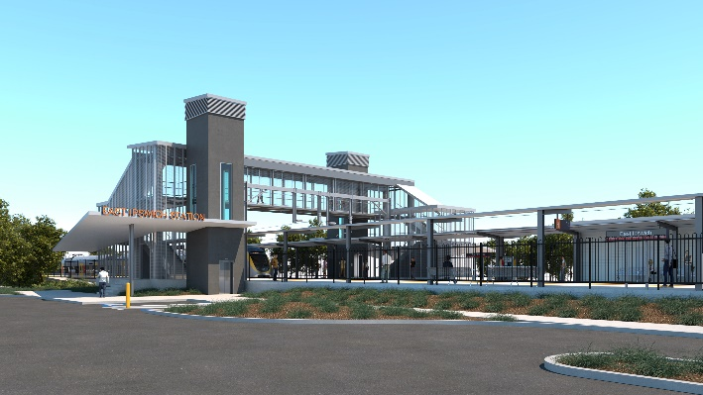
East Ipswich station accessibility upgrade

WORKS NOTICE

Night works – overhead line infrastructure

Monday 25 and Tuesday 26 November 2019

As part of the preliminary works for the East Ipswich station accessibility upgrade, Queensland Rail will adjust overhead line infrastructure between 6pm and 6am the next day over two nights on Monday 25 and Tuesday 26 November 2019 (weather and construction conditions permitting).
These works can only be undertaken at night when there is reduced rail traffic and the overhead power is switched off. Nearby residents may notice construction activities and associated noise in the rail corridor.

Overview of night works
Queensland Rail Limited ABN 71 132 181 090
Location | Dates and hours of work | Type of work
East Ipswich site:  - Brisbane-end of existing East Ipswich station, near Coronation and Merton Streets  Rail corridor access gates:  - Irvine and Bunya Streets, East Ipswich (all nights)  - Roma Street, Booval and Booval station carpark  - Coronation and Merton Streets, East Ipswich | 6pm to 6am the next day on:  - Monday 25 November  - Tuesday 26 November  (over 2 nights) | Adjustments to overhead line infrastructure involving:  - operation of height access equipment, trucks and on-track vehicles with flashing lights and reversing beepers  - operation of power tools and hand-held equipment  - movement of personnel and vehicles around the station precincts, rail corridor and access gates  - use of portable lighting towers at night.

Every effort will be made to minimise disruption and inconvenience as we work to improve your station.
The East Ipswich station accessibility upgrade is part of the State Government’s $357 million program to upgrade stations across the South East Queensland network, making them accessible for all customers.
For more information, please contact the project’s community team on free call 1800 722 203 or email stationsupgrade@qr.com.au

We are moving towards paperless notifications about noise and works. You will still see paper notices as we transition to the new system. Sign up at queenslandrail.com.au/EmailNotification or contact us if you prefer to receive paper copies.

