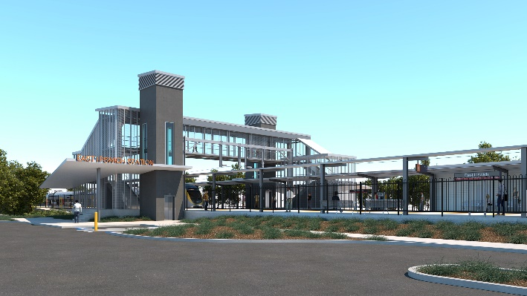
East Ipswich station accessibility upgrade

WORKS NOTICE

Preliminary works – rail corridor

Saturday 3 and Sunday 4 August 2019

In preparation for the East Ipswich station accessibility upgrade, Queensland Rail will undertake preliminary works during a scheduled track closure on Saturday 3 and Sunday 4 August 2019, weather and construction conditions permitting.
These activities include piling, which involves boring (or drilling) deep into the ground and backfilling with steel and concrete to form the foundation for the new overhead line infrastructure.
Some piling and concreting works near the station precinct (Merton and Coronation Streets) will be undertaken in the week prior to this weekend track closure.
All works will be undertaken during daytime hours (6am to 6pm).

Overview of works
Queensland Rail Limited ABN 71 132 181 090
Location | Dates and hours of work | Type of work
East Ipswich station (near Merton Street and Coronation Street carpark)  Vigoro fields (near rail corridor), access from Joyce Street  Rail corridor near East Ipswich station and Irvine/Marcel Streets  Access gate (corner of Bunya and Barrett Streets near Railway Street) | 6am to 6pm on:  - Saturday 3 and Sunday 4 August  (day works only)  Note:  Some piling and concreting near the station will be undertaken during the week prior to the weekend track closure. | Works within the rail corridor including:  - operation of piling rig, cranes, on-track vehicles, trucks and height access equipment with flashing lights and reversing beepers  - laydown of materials and construction of hardstand  - excavation works  - pouring concrete  - operation of powered tools and hand-held equipment  - movement of personnel and vehicles around the station precinct, rail corridor and access gates.

Every effort will be made to minimise disruption and inconvenience as we work to improve your station.
Queensland Rail will undertake further early works in the coming months. Residents will be provided advance notification of any after hours activities (nights, Sunday and public holidays) as required. Main station upgrade construction is expected to commence in mid to late 2020.
The East Ipswich station accessibility upgrade is part of Queensland Rail’s program to upgrade stations across the South East Queensland network, making them accessible for all customers.
For more information about the East Ipswich station accessibility upgrade, please contact the project’s community team during business hours on 1800 722 203 (free call) or email stationsupgrade@qr.com.au

We are moving towards paperless notifications about noise and works. You will still see paper notices as we transition to the new system. Sign up at queenslandrail.com.au/EmailNotification or contact us if you prefer to receive paper copies.

