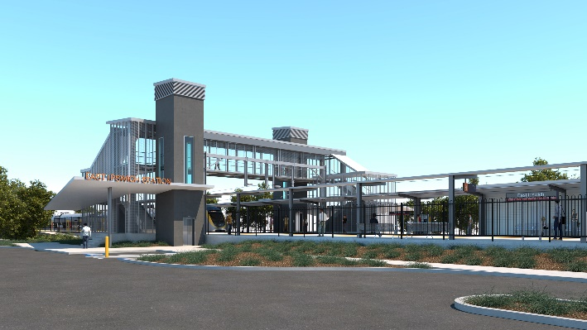
East Ipswich station accessibility upgrade

WORKS NOTICE

After hours works – rail corridor

January 2020

As part of the preliminary works for the East Ipswich station accessibility upgrade, Queensland Rail will undertake continued early works in January 2020, weather and construction conditions permitting.
These works can only be undertaken at night when there is reduced rail traffic and the overhead power is switched off. Nearby residents may notice construction activities and associated noise in the rail corridor.
Every effort will be made to minimise disruption and inconvenience as we work to improve your station.

Overview of after hours works
Queensland Rail Limited ABN 71 132 181 090
Location | Dates and hours of work | Type of work
East Ipswich station precinct and rail corridor  Rail corridor access gates:  - Irvine and Bunya Streets, East Ipswich (all nights)  - Coronation and Merton Streets, East Ipswich | Preparation works before track closure:  8pm to 5am the next day on:  - Wednesday 1 to Friday 10 January  (over 10 nights)  During scheduled track closure:  - 6am Saturday 18 to 5am Monday 20 January  (continuous works) | Station accessibility preliminary works:  - operation of lifting equipment including cranes, trucks and height access equipment with flashing lights and reversing beepers  - installation of overhead line infrastructure  - wiring modification works  - on-track maintenance vehicles accessing the rail corridor  - operation of power tools and hand-held equipment  - movement of personnel and vehicles around the station precincts, rail corridor and access gates  - pouring concrete  - use of portable lighting towers at night.

The East Ipswich station accessibility upgrade is part of the State Government’s $357 million investment to upgrade stations across the South East Queensland network, making them accessible for all customers.
For more information, please contact the project’s community team on free call 1800 722 203 or email stationsupgrade@qr.com.au

We are moving towards paperless notifications about noise and works. You will still see paper notices as we transition to the new system. Sign up at queenslandrail.com.au/EmailNotification or contact us if you prefer to receive paper copies.

