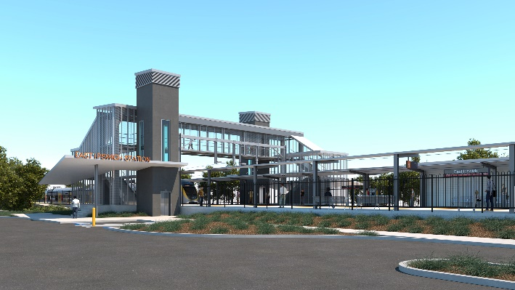
East Ipswich station accessibility upgrade

WORKS NOTICE

After hours works – rail corridor

Late September to mid-October 2019

As part of the preliminary works for the East Ipswich station accessibility upgrade, Queensland Rail will relocate two electrical booster transformers from East Ipswich station to their new location near Booval station during night works in late September/mid-October 2019, weather and construction conditions permitting.
These works can only be undertaken at night when there is reduced rail traffic and the overhead power is switched off. Nearby residents may notice construction activities and associated noise in the rail corridor.
An overview of after hours works is provided in the table below. Note: The specified nights and locations may change without notice, depending on rail freight movements on the local network and the Ipswich rail yard.
Overview of after hours works
Queensland Rail Limited ABN 71 132 181 090
Location | Dates and hours of work | Type of work
Booval site:  - Ipswich-end of Booval station, near Roma and Railway Streets  East Ipswich site:  - Brisbane-end of existing East Ipswich station, near Coronation and Merton Streets  Rail corridor access gates:  - Irvine and Bunya Streets, East Ipswich (all nights)  - Roma Street, Booval and Booval station carpark  - Coronation and Merton Streets, East Ipswich | 6pm to 5am the next day on:  - Sunday 29 September to Tuesday 1 October  (over 3 nights – Booval)  - Wednesday 2 and Thursday 3 October  (over 2 nights – East Ipswich)  - Sunday 6 to Tuesday 8 October  (over 3 nights – Booval)  - Wednesday 9 and Thursday 10 October  (over 2 nights – East Ipswich)  6am to 10pm each day on:  - Saturday 12 and Sunday 13 October  (scheduled track closure)  6pm to 5am the next day on:  - Sunday 13 to Thursday 17 October  (over 5 nights – East Ipswich) | Station accessibility preliminary works:  - operation of lifting equipment including cranes, trucks and height access equipment with flashing lights and reversing beepers  - installation of overhead line infrastructure  - wiring modification works near Booval station  - on-track maintenance vehicles accessing the rail corridor  - operation of power tools and hand-held equipment  - movement of personnel and vehicles around the station precincts, rail corridor and access gates  - pouring concrete  - use of portable lighting towers at night.

Overhead line infrastructure works planned for October will continue as previously notified to residents in the vicinity of East Ipswich station.
Every effort will be made to minimise disruption and inconvenience as we work to improve your station. For more information, please contact the project’s community team on free call 1800 722 203 or email stationsupgrade@qr.com.au

We are moving towards paperless notifications about noise and works. You will still see paper notices as we transition to the new system. Sign up at queenslandrail.com.au/EmailNotification or contact us if you prefer to receive paper copies.

