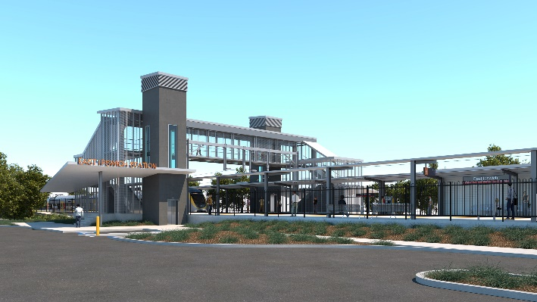
East Ipswich station accessibility upgrade

WORKS NOTICE

Preliminary works (after hours) and temporary carpark changes

- Carpark: September 2019 to late January 2020
- After hours works: October 2019 and January 2020

In preparation for the East Ipswich station accessibility upgrade, Queensland Rail will undertake preliminary works on selected dates in October 2019 and January 2020 to install overhead line infrastructure.
To support these preliminary works, a project compound and laydown area will be established at the western end of the main station carpark, corner of Cotton and Merton Streets (see map over the page). Approximately 20 spaces will be temporarily unavailable from Monday 16 September 2019 until late January 2020, weather and construction conditions permitting.
Nearby residents may notice project construction activities and associated noise in the station carpark and around the station precinct/rail corridor. See the table below for an overview of after hours activities. Some additional works may be scheduled on Queensland Rail property during regular daytime working hours.
Overview of after hours works
Queensland Rail Limited ABN 71 132 181 090
Location | Dates and hours of work | Type of work
East Ipswich station  Station carpark (corner of Cotton and Merton Streets)  Rail corridor near East Ipswich station and access gates (Coronation and Merton Streets) | 6am to 10pm each day on:  - Saturday 12 and Sunday 13 October 2019  - Saturday 18 and Sunday 19 January 2020.  Note: Works may also be scheduled at other times, such as during regular daytime working hours. | Station accessibility preliminary works, including:  - installation of overhead line infrastructure  - operation of cranes, on-track vehicles, trucks and height access equipment with flashing lights and reversing beepers  - laydown of materials in the carpark  - pouring concrete  - operation of powered tools and hand-held equipment  - movement of personnel and vehicles around the station precinct, rail corridor and access gates  - portable lighting towers at night.

Every effort will be made to minimise disruption and inconvenience as we work to improve your station.
For more information about the East Ipswich station accessibility upgrade, please contact the project’s community team during business hours on 1800 722 203 (free call) or email stationsupgrade@qr.com.au

We are moving towards paperless notifications about noise and works. You will still see paper notices as we transition to the new system. Sign up at queenslandrail.com.au/EmailNotification or contact us if you prefer to receive paper copies.

East Ipswich station accessibility upgrade – temporary carpark changes

September 2019 to late January 2020

To support preliminary works for the East Ipswich station accessibility upgrade, a project compound and laydown area will be established at the western end of the main station carpark, corner of Cotton and Merton Streets.
Approximately 20 spaces will be temporarily unavailable from Monday 16 September 2019 until late January 2020, weather and construction conditions permitting.
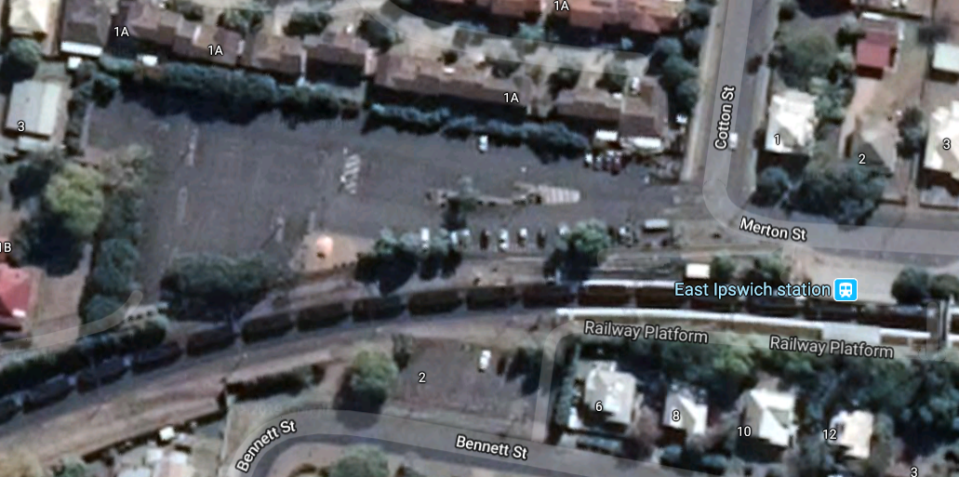

Section of carpark closed until late January 2020
Map data ©2019 Google

Truck route eg. deliveries/laydown

Queensland Rail will undertake further early works in the coming months. Main construction for the station accessibility upgrade is expected to commence in mid to late 2020.
Local residents will be given advance notification of construction activities likely to cause impacts, including after hours work (nights, Sundays and public holidays, as required).
The East Ipswich station accessibility upgrade is part of Queensland Rail’s program to upgrade stations across the South East Queensland network, making them accessible for all customers.
For more information about the East Ipswich station accessibility upgrade, please contact the project’s community team during business hours on 1800 722 203 (free call) or email stationsupgrade@qr.com.au

