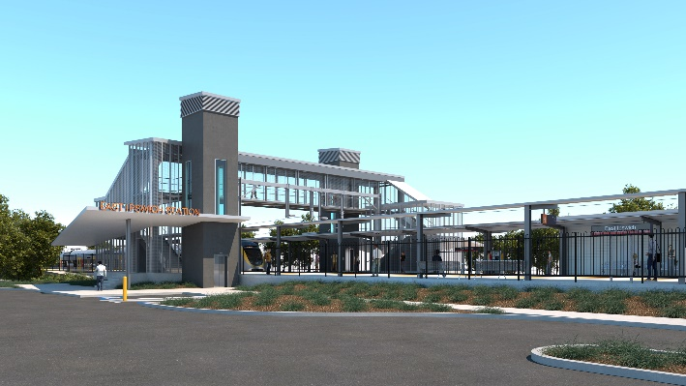
East Ipswich station accessibility upgrade

WORKS NOTICE

Acoustic investigations (noise monitoring)

November 2019

As part of the preliminary works for the East Ipswich station accessibility upgrade, Queensland Rail will undertake acoustic monitoring investigations near the station between Thursday 21 and Thursday 28 November 2019, weather and construction conditions permitting.
The unattended acoustic monitoring equipment (or ‘noise logger’) is a small box that will be attached to rail corridor fencing or a pole. The logger takes noise readings which will be used as baseline data to inform station upgrade design development.
In addition to unattended noise logger monitoring, project contractors will be supplementing this data with other observations of train movements and attended handheld noise monitoring. Attended monitoring will occur at selected common access (public) areas near the station.
No access to private property will be required unless prior property owner consent has been obtained.
These assessments are standard investigations undertaken to understand the noise impacts associated with the new or changed rail transport infrastructure.

Overview of activities
Queensland Rail Limited ABN 71 132 181 090
Location | Dates and hours of work | Type of work
East Ipswich station and rail corridor (near Merton and Coronation Streets) | Thursday 21 to Thursday 28 November | Noise monitoring involving:  - noise logger equipment temporarily installed on station property (eg. fence or pole)  - presence of project contractors on or near Queensland Rail property.
Overhead line infrastructure works planned for October will continue as previously notified to residents in the vicinity of East Ipswich station.
Every effort will be made to minimise disruption and inconvenience as we work to improve your station.
For more information, please contact the project’s community team on free call 1800 722 203 or email stationsupgrade@qr.com.au

We are moving towards paperless notifications about noise and works. You will still see paper notices as we transition to the new system. Sign up at queenslandrail.com.au/EmailNotification or contact us if you prefer to receive paper copies.

