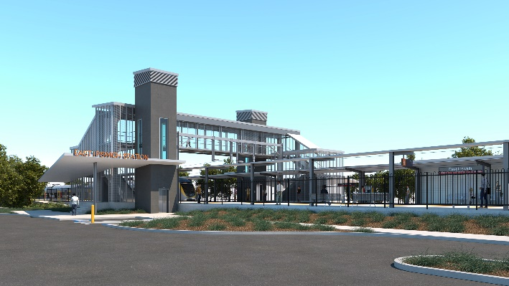
East Ipswich station accessibility upgrade

WORKS NOTICE

After hours (weekend) works

January 2022

As part of the East Ipswich station accessibility upgrade, Queensland Rail will undertake after hours (weekend) works on Saturday 15 and Sunday 16 January 2022, between 5am and 8pm each day (weather and construction conditions permitting).
Activities may include demolition works, operation of heavy machinery and equipment as well as the movement of vehicles around the station precinct.
Where possible, noisy works will be scheduled during daytime shifts.
While not anticipated for this weekend, overnight works may be required due to changed weather or construction conditions.
These works have been planned during a scheduled closure of the Ipswich/Rosewood line when buses will replace trains. Traffic management may be required to assist with the movement of vehicles and deliveries near the work zones.
Every effort will be made to minimise disturbance wherever possible. We apologise for any inconvenience and appreciate your patience as we undertake these important works.
Overview of works
Queensland Rail Limited ABN 71 132 181 090
Location | Dates and hours of work | Type of work
East Ipswich station precinct and rail corridor  Station carparks  Rail corridor access gates:  - Merton Street  - Coronation Street | Weekend works during track closure:  5am to 8pm on:  - Saturday 15 January  - Sunday 16 January  Note: Nights will only be worked if required due to changed weather or construction conditions. | Station upgrade works involving:  - demolition works – concrete cutting  - operation of heavy machinery and equipment  - use of hand-held equipment and powered tools  - operation of heavy equipment and trucks with flashing lights and reversing beepers  - movement of personnel and vehicles around the station precinct and rail corridor  - traffic management (if required) – Bennett, Coronation and Merton Streets  - use of lighting towers (in the event of night works).
The East Ipswich station accessibility upgrade is part of the State Government’s ongoing investment of more than $500 million to upgrade stations across the South East Queensland network, making them accessible for all customers.
For more information, please contact the project’s community team on free call 1800 722 203 or email stationsupgrade@qr.com.au

Sign up for electronic notifications at queenslandrail.com.au/EmailNotification

