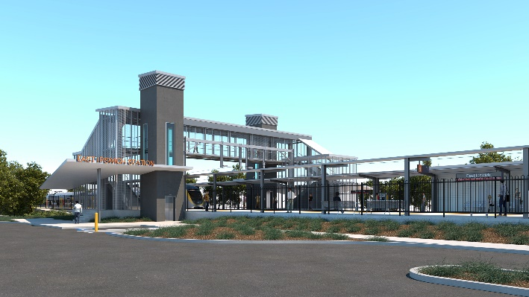
East Ipswich station accessibility upgrade

WORKS NOTICE

Day works – overhead foundation removal (jackhammering)

Wednesday 26 to Friday 28 August 2020

As part of the East Ipswich station accessibility upgrade, Queensland Rail will undertake overhead foundation removal activities, involving jackhammers and rock-breakers, over three day shifts from Wednesday 26 to Friday 28 August 2020 (weather and construction conditions permitting).
While all works will be undertaken during normal daylight working hours, these activities are expected to create significant noise.
Every effort will be made to minimise disruption and we apologise in advance for any inconvenience caused as we undertake these essential works.
Overview of works
Queensland Rail Limited ABN 71 132 181 090
Location | Dates and hours of work | Type of work
East Ipswich station precinct, carparks and rail corridor  Rail corridor access gate:  - Merton Street, East Ipswich | 6.30am to 6.30pm on:  - Wednesday 26 August  - Thursday 27 August  - Friday 28 August  (day works only) | Foundation removal (overhead infrastructure):  - operation of heavy equipment including jackhammers and rock-breakers  - operation of hand-held equipment  - movement of personnel and vehicles around the station precinct, rail corridor and access gates.

Novel Coronavirus (COVID-19) – Queensland Rail is committed to keeping essential rail services operating for Queenslanders during this challenging time and to do this, network maintenance and critical capital works must continue. To support workforce safety, Queensland Rail has implemented a number of additional control measures related to COVID-19 management. We will continue to take the necessary precautions to ensure the ongoing health and wellbeing of our team and the communities in which we operate.

The East Ipswich station accessibility upgrade is part of the State Government’s $357 million investment to upgrade stations across the South East Queensland network, making them accessible for all customers.
For more information, please contact the project’s community team on free call 1800 722 203 or email stationsupgrade@qr.com.au

Sign up for paperless notifications at queenslandrail.com.au/EmailNotification

