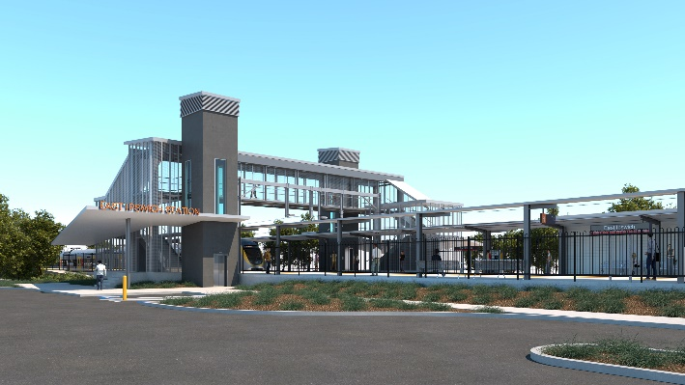
East Ipswich station accessibility upgrade

WORKS NOTICE

Night activities – station lighting commissioning

Tuesday 5 and Wednesday 6 October 2021

As part of the East Ipswich station accessibility upgrade, the station’s new system of lighting (including footpath lighting) will be commissioned next week, including night activities on Tuesday 5 and Wednesday 6 October.
This requires all lights throughout the precinct to be switched on at full capacity and operate continuously (day and night) for approximately 30 hours.
Nearby residents will notice increased lighting overnight and this is a necessary part of commissioning the lighting design. Commissioning activities are not expected to create excessive noise and the project team will make every effort to minimise disturbance wherever possible.
We apologise for any inconvenience and appreciate your understanding as we take this important step towards project completion.
Upon commissioning of the new lighting system, the station’s lights will operate nightly as they would under normal operational conditions.
Overview of works
Queensland Rail Limited ABN 71 132 181 090
Location | Dates and hours of work | Type of work
East Ipswich station precinct  Adjacent footpaths:  - Merton Street  - Coronation Street  Work zones and site offices | Night activities:  6pm to 6am the next day on:  - Tuesday 5 October  - Wednesday 6 October  (over two nights)  Note: Lighting will be switched on continuously, day and night, for approximately 30 hours. | Station and footpath lighting commissioning:  - lighting system operating continuously, day and night  - electrical and switchboard activities  - use of hand-held equipment and powered tools  - movement of personnel and vehicles around the station precinct and rail corridor  - use of light towers to light work zones at night.

The East Ipswich station accessibility upgrade is part of the State Government’s ongoing investment of more than $500 million to upgrade stations across the South East Queensland network, making them accessible for all customers.
For more information, please contact the project’s community team on free call 1800 722 203 or email stationsupgrade@qr.com.au

Sign up for electronic notifications at queenslandrail.com.au/EmailNotification

