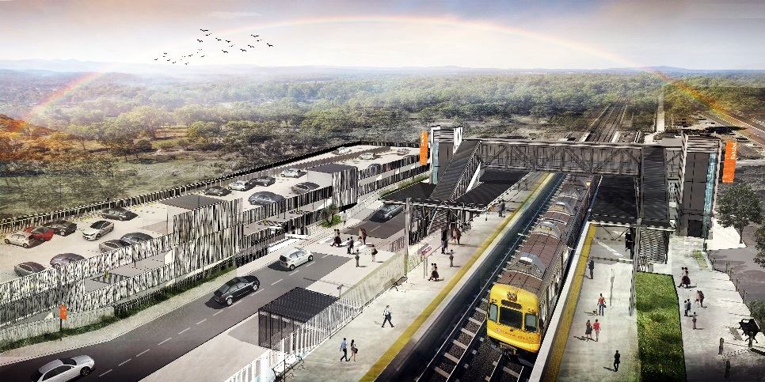
Dakabin station accessibility upgrade

WORKS NOTICE

Weekend works

Saturday 2 and Sunday 3 May 2020

As part of the Dakabin station accessibility upgrade, Queensland Rail will undertake weekend works on Saturday 2 and Sunday 3 May, 6.30am to 6.30pm (weather and construction conditions permitting).
These activities are a continuation of those commenced Monday 27 to Thursday 30 April and will involve screw piling (drilling), demolition of platform waiting shelters and tree removal on Thompson Road in preparation for construction of the new multi-storey carpark. Ongoing station water and sewer main connection works continue.
Nearby residents may experience some noise associated with construction activities and the operation of heavy machinery. These works have been scheduled after hours when there is reduced rail traffic and fewer customers. The removal of trees is necessary to construct the multi-storey carpark and will be carried out under environmental approval with measures in place to ensure the safety of local fauna.
Normal working hours have been reviewed and will be 6.30am to 6.30pm, Monday to Saturday, throughout the station upgrade project. Every effort will be made to minimise disruption and inconvenience as we work to improve your station.

Overview of after hours works
Queensland Rail Limited ABN 71 132 181 090
Location | Dates and hours of work | Type of work
Dakabin station precinct and adjacent rail corridor  Carpark (Narangba Road side) – closed Monday 27 and Tuesday 28 April  Thompson Road (near station) – under traffic control Wednesday 29 and Thursday 30 April | - Saturday 2 and Sunday 3 May, 6.30am to 6.30pm each day | Station upgrade works involving:  - establishment of site compounds  - demolition and removal of platform shelters  - excavation, screw piling (drilling) and service installations (water, sewer and electrical)  - tree/vegetation removal (Thompson Road footpath, near main carpark)  - operation of cranes, heavy equipment and trucks with flashing lights and reversing beepers  - use of powered tools and hand-held equipment  - movement of personnel and vehicles around the station precinct and rail corridor  - temporary closure of Narangba Road carpark for lifting activities  - traffic management on Thompson Road.
Novel Coronavirus (COVID-19) – Queensland Rail is committed to keeping essential rail services operating for Queenslanders during this challenging time and to do this, network maintenance and critical capital works must continue. To support workforce safety, Queensland Rail has implemented a number of additional control measures related to COVID-19 management. We will continue to take the necessary precautions to ensure the ongoing health and wellbeing of our team and the communities in which we operate.
The Dakabin station accessibility upgrade is part of Queensland Rail’s $357 million investment to upgrade stations across the South East Queensland network, making them accessible for all customers. For more information about the upgrade, please contact the project’s community team during business hours on 1800 722 203 (free call) or email stationsupgrade@qr.com.au

Sign up for paperless notifications at queenslandrail.com.au/EmailNotification

