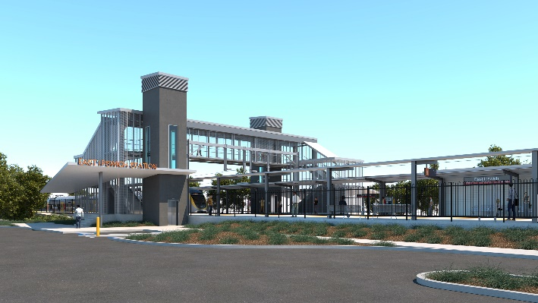
East Ipswich station accessibility upgrade

WORKS NOTICE

Night works – telecommunication cabling

Saturday 15 August 2020

Service provider TPG has scheduled critical optical fibre works and will undertake activities within the rail corridor near East Ipswich station on Saturday 15 August 2020, from 6pm until 6am the next day (weather and construction conditions permitting).
For safety, these works can only be undertaken after hours, when train services are reduced.
Works involve pulling cabling through underground conduits within the rail corridor and connection with the existing optical fibre infrastructure.
While, nearby residents may notice some noise associated with these activities, works are not expected to be excessively noisy. Queensland Rail’s site inspectors will be present to monitor these external works.
We apologise for any inconvenience caused due to the change in the service provider’s program.
Overview of after hours works
Location | Dates and hours of work | Type of work  Queensland Rail Limited ABN 71 132 181 090
East Ipswich station precinct and rail corridor  Rail corridor access gate:  - Merton Street, East Ipswich | 6pm to 6am the next day on:  - Saturday 15 August  (overnight) | Optical fibre activities including:  - installation of optical fibre – pulling cable underground  - operation of hand-held equipment  - movement of personnel and vehicles around the station precinct, rail corridor and access gates  - use of portable lighting towers at night.

Novel Coronavirus (COVID-19) – Queensland Rail is committed to keeping essential rail services operating for Queenslanders during this challenging time and to do this, network maintenance and critical capital works must continue. To support workforce safety, Queensland Rail has implemented a number of additional control measures related to COVID-19 management. We will continue to take the necessary precautions to ensure the ongoing health and wellbeing of our team and the communities in which we operate.
The East Ipswich station accessibility upgrade is part of the State Government’s $357 million investment to upgrade stations across the South East Queensland network, making them accessible for all customers.
For more information, please contact the project’s community team on free call 1800 722 203 or email stationsupgrade@qr.com.au

Sign up for paperless notifications at queenslandrail.com.au/EmailNotification

