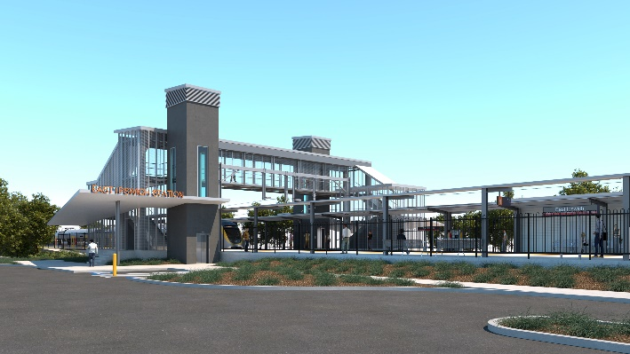
East Ipswich station accessibility upgrade

WORKS NOTICE

Night works

February 2021

As part of the East Ipswich station accessibility upgrade, Queensland Rail will undertake concrete pours for the new station platforms each night from Monday 8 to Saturday 13 February 2021.
Track resurfacing activities will also be undertaken over two nights on Sunday 21 and Monday 22 February 2021.
Due to the nature and location of these works, activities have been scheduled after hours when there is reduced rail traffic on the line. Dates may be subject to change due to weather and other construction conditions.
Every effort will be made to minimise disturbance wherever possible. We apologise for any inconvenience and appreciate your patience as we undertake these important works.
Overview of works
Queensland Rail Limited ABN 71 132 181 090
Location | Dates and hours of work | Type of work
East Ipswich station precinct and rail corridor  Rail corridor access gates:  - Merton Street  - Coronation Street | Concrete pour:  7pm to 5am the next day on:  - Monday 8 February  - Tuesday 9 February  - Wednesday 10 February  - Thursday 11 February  - Friday 12 February  - Saturday 13 February  (over 6 nights)  Track works:  7pm to 5am the next day on:  - Sunday 21 February  - Monday 22 February  (over 2 nights) | Station upgrade and associated works involving:  - pouring concrete slabs – new platforms (8-13 February)  - operation of concrete trucks, pumps and vibrating equipment  - track works (21 and 22 February), including cutting and welding of rail and loading and unloading of ballast  - use of hand-held equipment and powered tools  - operation of heavy equipment, on-track vehicles and trucks with flashing lights and reversing beepers  - movement of personnel and vehicles around the station precinct and rail corridor  - traffic management – Coronation and Merton Streets  - use of lighting towers at night.
The East Ipswich station accessibility upgrade is part of the State Government’s investment of more than $500 million to upgrade stations across the South East Queensland network, making them accessible for all customers. For more information, please contact the project’s community team on free call 1800 722 203 or email stationsupgrade@qr.com.au

