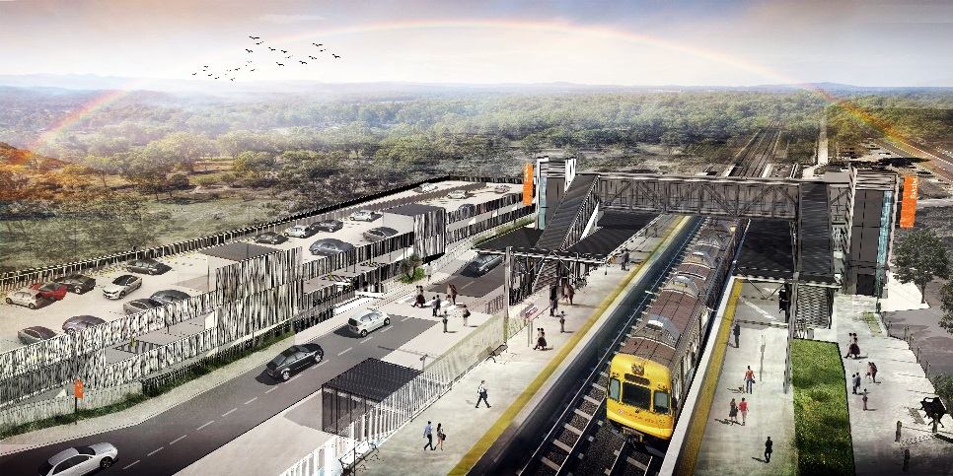
Dakabin station accessibility upgrade

WORKS NOTICE

Night works – overhead equipment

- Monday 3 to Thursday 6 June 2019
- Monday 17 to Thursday 20 June 2019
- Monday 24 to Thursday 27 June 2019

In preparation for the Dakabin station accessibility upgrade, Queensland Rail will undertake overhead infrastructure works from 8pm to 5am the next morning on selected nights in June.
Due to the availability of equipment and personnel, night works planned for July have been rescheduled to commence on Monday 3 June. We apologise for the late notice resulting from this programming change.
Works will involve the installation of steel masts to support overhead lines. Every effort will be made to minimise disruption and inconvenience as we work to improve your station.
For the safety of workers and to maintain rail services, these works can only be undertaken at night when there are fewer services operating and when the overhead power is switched off.

Overview of night works
Location | Dates and hours of work | Type of work  Queensland Rail Limited ABN 71 132 181 090
Dakabin station  Rail corridor  (up to 200 metres from either end of station precinct) | 8pm to 5am the next day on:  - Monday 3 to Thursday 6 June  (over 4 nights)  - Monday 17 to Thursday 20 June  (over 4 nights)  - Monday 24 to Thursday 27 June  (over 4 nights) | Overhead infrastructure works involving:  - operation of cranes, on-track vehicles, trucks and height access equipment with flashing lights and reversing beepers  - operation of powered tools and hand-held equipment  - movement of personnel and vehicles around the station precinct and rail corridor  - portable lighting towers.

Main construction for the station accessibility upgrade is expected to commence in late 2019.
The Dakabin station accessibility upgrade is part of Queensland Rail’s program to upgrade stations across the South East Queensland network, making them accessible for all customers.
For more information about the upgrade, please contact the project’s community team during business hours on 1800 722 203 (free call) or email stationsupgrade@qr.com.au

We are moving towards paperless notifications about noise and works. You will still see paper notices as we transition to the new system. Sign up at queenslandrail.com.au/EmailNotification or contact us if you prefer to receive paper copies.

