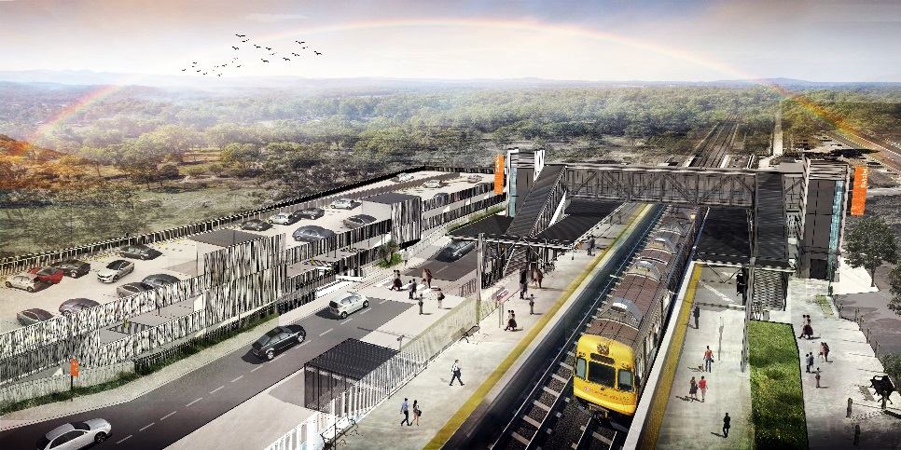
Dakabin station accessibility upgrade

WORKS NOTICE

Night works – assessment of overhead equipment
Sunday 17 and Monday 18 March 2019

Queensland Rail will undertake preliminary works on Sunday 17 and Monday 18 March 2019 (8pm to 4am each night), in preparation for the Dakabin station accessibility upgrade.
These works involve the assessment of overhead equipment (recording measurements of heights and locations) to enable station upgrade works later in the year.
For the safety of workers and to maintain rail services, these works can only be undertaken at night when there are no services operating and the overhead power is switched off.
Crews with on-track vehicles will access the rail corridor at the level crossing at Mackie Road, Narangba.
Every effort will be made to minimise disruption and we apologise for any inconvenience as we work to improve your station.

Overview of work
Location | Dates and hours of work | Type of work  Queensland Rail Limited ABN 71 132 181 090
Dakabin station  Rail corridor  (up to 200 metres from either end of station precinct)  Level crossing, Mackie Road, Narangba  (track access) | 8pm to 4am the next day on:  - Sunday 17 March  - Monday 18 March  (over 2 nights) | Overhead infrastructure works involving:  - on-track vehicles, trucks and height access equipment with flashing lights and reversing beepers  - the use of laser measurement equipment and height poles  - movement of personnel and vehicles around the station precinct and rail corridor  - portable lighting towers.

Main construction for the station accessibility upgrade is expected to commence in late 2019.
The Dakabin station accessibility upgrade is part of Queensland Rail’s $300 million program to upgrade stations across the South East Queensland network, making them accessible for all customers.
For more information about the upgrade, please contact the project’s community team during business hours on 1800 722 203 (free call) or email stationsupgrade@qr.com.au

We are moving towards paperless notifications about noise and works. You will still see paper notices as we transition to the new system. Sign up at queenslandrail.com.au/EmailNotification or contact us if you prefer to receive paper copies.

