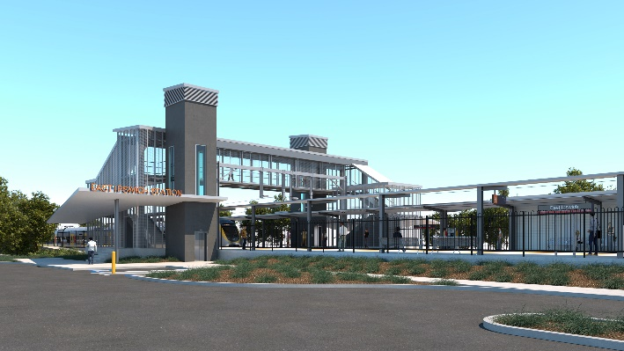
East Ipswich station accessibility upgrade

WORKS NOTICE

Night works

March 2021

As part of the East Ipswich station accessibility upgrade, Queensland Rail will undertake concrete pours for the new station platforms between 7pm and 5am the next day from Monday 8 to Saturday 13 and again from Monday 15 to Saturday 20 March.
Due to the nature and location of these works, activities have been scheduled after hours when there is reduced rail traffic on the line. Dates may be subject to change due to weather and other construction conditions.
Every effort will be made to minimise disturbance wherever possible. We apologise for any inconvenience and appreciate your patience as we undertake these important works.
Overview of works
Queensland Rail Limited ABN 71 132 181 090
Location | Dates and hours of work | Type of work
East Ipswich station precinct and rail corridor  Rail corridor access gates:  - Merton Street  - Coronation Street | 7pm to 5am the next day on:  - Monday 8 to Friday 12 March  (over 5 nights)  - Monday 15 to Friday 19 March  (over 5 nights) | Station upgrade and associated works involving:  - pouring concrete slabs – new platforms (8-13 March and 15-20 March)  - operation of concrete trucks, pumps and vibrating equipment  - use of hand-held equipment and powered tools  - operation of heavy equipment, on-track vehicles and trucks with flashing lights and reversing beepers  - movement of personnel and vehicles around the station precinct and rail corridor  - traffic management – Coronation and Merton Streets  - use of lighting towers at night.
The East Ipswich station accessibility upgrade is part of the State Government’s investment of more than $500 million to upgrade stations across the South East Queensland network, making them accessible for all customers.
For more information, please contact the project’s community team on free call 1800 722 203 or email stationsupgrade@qr.com.au

