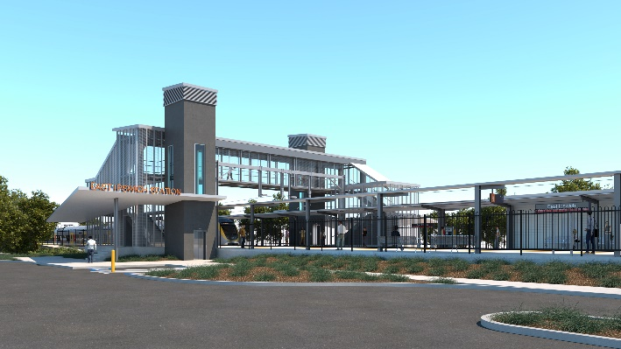
East Ipswich station accessibility upgrade

WORKS NOTICE

Night works – electrical and signalling systems

Monday 29 November 2021

In preparation for commencing operations of the new East Ipswich station building and infrastructure, Queensland Rail will undertake station commissioning works overnight on Monday 29 November 2021, 8pm until 5am the next day (weather and construction conditions permitting).
Activities include testing and commissioning the electrical and signalling systems and involve the use of hand tools and vehicle movements around the station precinct.
Due to the nature of these activities, works can only be undertaken out of hours when rail traffic is reduced.
Every effort will be made to minimise disturbance wherever possible. We apologise for any inconvenience and appreciate your patience as we undertake these important woks.

Overview of works
Queensland Rail Limited ABN 71 132 181 090
Location | Dates and hours of work | Type of work
East Ipswich station precinct and rail corridor | Monday 29 November, 8pm to 5am the next day  (overnight works) | Station commissioning activities involving:  - testing of electrical and signalling systems  - use of hand-held equipment and powered tools  - operation of trucks and project vehicles with flashing lights and reversing beepers  - movement of personnel and vehicles around the station precinct and rail corridor  - use of lighting towers at night.

The East Ipswich station accessibility upgrade is part of the State Government’s ongoing investment of more than $500 million to upgrade stations across the South East Queensland network, making them accessible for all customers.
For more information, please contact the project’s community team on free call 1800 722 203 or email stationsupgrade@qr.com.au

