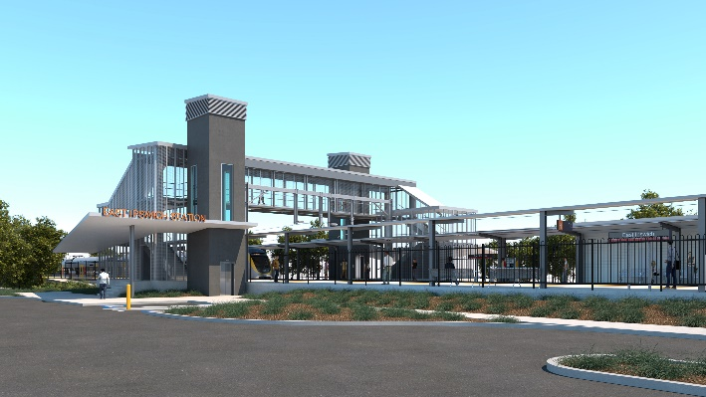
East Ipswich station accessibility upgrade

WORKS NOTICE

Night works – platform foundations

Wednesday 7 and Thursday 8 October 2020

As part of the East Ipswich station accessibility upgrade, Queensland Rail will undertake foundation screw piling (drilling) works from 6pm to 6am the next day over two nights, on Wednesday 7 and Thursday 8 October 2020 (weather and construction conditions permitting).
These works can only be undertaken when there is reduced rail traffic and the overhead power is switched off. Screw piling has been chosen specifically for this location to minimise noise and dust.
While nearby residents may still notice some noise associated with construction activities in the vicinity of the work zone, every effort will be made to minimise disruption and we apologise for any inconvenience as we undertake these important works.
Overview of works
Location | Dates and hours of work | Type of work
East Ipswich station precinct (including carparks and rail corridor) | 6pm to 6am the next day on:  - Wednesday 7 October  - Thursday 8 October  (over 2 nights) | Foundation works involving:  - screw piling (drilling) on platform and in the rail corridor for foundations  Queensland Rail Limited ABN 71 132 181 090  - operation of excavators and trucks with bright flashing lights and reversing beepers  - operation of power tools and hand-held equipment  - movement of personnel and vehicles around the station precinct, rail corridor and project compound  - use of portable lighting towers at night  - traffic management (Merton Street and Coronation Street).
The East Ipswich station accessibility upgrade is part of the State Government’s investment to upgrade stations across the South East Queensland network, making them accessible for all customers.
For more information, please contact the project’s community team on free call 1800 722 203 or email stationsupgrade@qr.com.au

