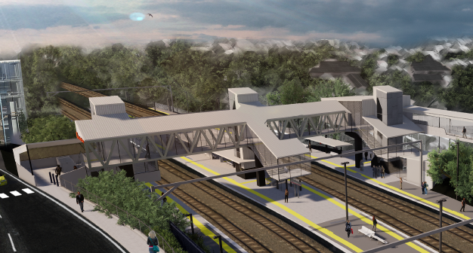
Auchenflower station accessibility upgrade

WORKS NOTICE

Night works – platform excavation
Sunday 1 December 2019

In preparation for the Auchenflower station accessibility upgrade, Queensland Rail will undertake excavation works on platform 1 (Lang Parade side) overnight on Sunday 1 December from 9pm to 4am the next day (weather and construction conditions permitting).
Works have been scheduled after hours for public safety.
Concreting works on the station platform will be undertaken on Tuesday 3 December during normal daytime working hours (after morning peak travel).
Nearby residents may experience noise associated with excavation activities and the operation of trucks around the work zone. Every effort will be made to minimise disruption and we apologise for any inconvenience as we undertake these important early works.

Overview of night works
Queensland Rail Limited ABN 71 132 181 090
Location | Dates and hours of work | Type of work
Auchenflower station:  - platform 1 (Lang Parade side) | 9pm to 4am the next day on:  Sunday 1 December  (overnight) | Station upgrade works involving:  - excavation on station platform using a vacuum excavation truck  - operation of machinery and trucks with flashing lights and reversing beepers  - hand-held tools and powered equipment  - movement of personnel and vehicles around the station precinct and in the rail corridor  - portable lighting towers in use at night.

The Auchenflower station accessibility upgrade is part of the State Government’s $357 million program to upgrade stations across the South East Queensland network, making them accessible for all customers.
For more information, please contact the project’s community team during business hours on free call 1800 722 203 or email stationsupgrade@qr.com.au

We are moving towards paperless notifications about noise and works. You will still see paper notices as we transition to the new system. Sign up at queenslandrail.com.au/EmailNotification or contact us if you prefer to receive paper copies.

