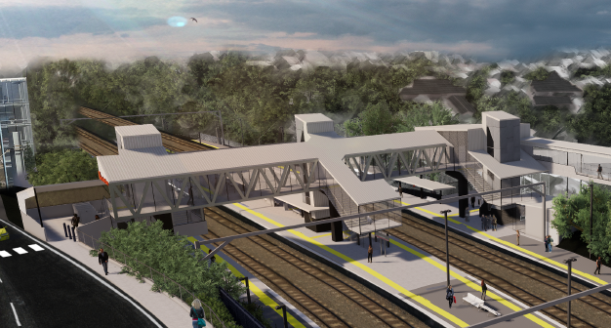
Auchenflower station accessibility upgrade

WORKS NOTICE

Foundation works and temporary road closure (Auchenflower Terrace)
October/November 2019

In preparation for the Auchenflower station accessibility upgrade, Queensland Rail will undertake foundation works (drilling or boring in rock) on platforms 1 and 4 between Tuesday 29 October and Friday 15 November 2019, weather and construction conditions permitting. Works have been scheduled outside of peak travel times, generally between 9am and 2pm (Monday to Friday).
During these works, Auchenflower Terrace will be closed and a traffic diversion in place (9am to 2pm daily – see map over the page). A lane closure under traffic control will be in operation in Lang Parade. Road users should observe the changed conditions and follow the instructions of the traffic controller. Access to private property will be maintained.
The station will continue to operate and customers will be separated from the work zone with temporary fencing and dedicated ‘spotter’ personnel for safety.
Platform works will also continue over a scheduled weekend track closure from 10pm Friday 8 until 4am Monday 11 November 2019.

Scheduled works
Queensland Rail Limited ABN 71 132 181 090
Location | Dates and hours of work | Type of work
Auchenflower station:  - platform 1 (Lang Parade side)  - platform 4 (Auchenflower Terrace side)  Auchenflower Terrace (road closure with traffic detour)  Lang Parade (lane closure)  Rail corridor access gate (near Dixon Street) | 9am to 2pm Monday to Friday between Tuesday 29 October and Friday 15 November  (day works, off peak) | Foundation drilling works involving:  - drilling (or boring) in rock and excavation on or near station platforms  - track maintenance  - operation of machinery and trucks with flashing lights and reversing beepers  - hand-held tools and powered equipment  - movement of personnel and vehicles around the station precinct and in the rail corridor  - road and lane closures with traffic management  - portable lighting towers in use at night.
10pm Friday 8 to 4am Monday 11 November
(around-the-clock works, scheduled track closure)
Nearby residents and businesses may experience noise associated with foundation drilling activities. Dust suppression measures will be in place. Every effort will be made to minimise disruption and we apologise for any inconvenience as we undertake these important early works.
Queensland Rail’s Auchenflower station accessibility upgrade is part of the program to upgrade stations across the South East Queensland network, making them accessible for all customers. For more information, please contact the project’s community team during business hours on free call 1800 722 203 or email stationsupgrade@qr.com.au

Page 2

Temporary road closure and traffic management
Auchenflower Terrace (road closure and detour) and Lang Parade (lane closure under traffic control)
- Off peak works: Tuesday 29 October to Friday 15 November, 9am to 2pm (Monday to Friday)
- Works during scheduled track closure: 10pm Friday 8 to 4am Monday 11 November

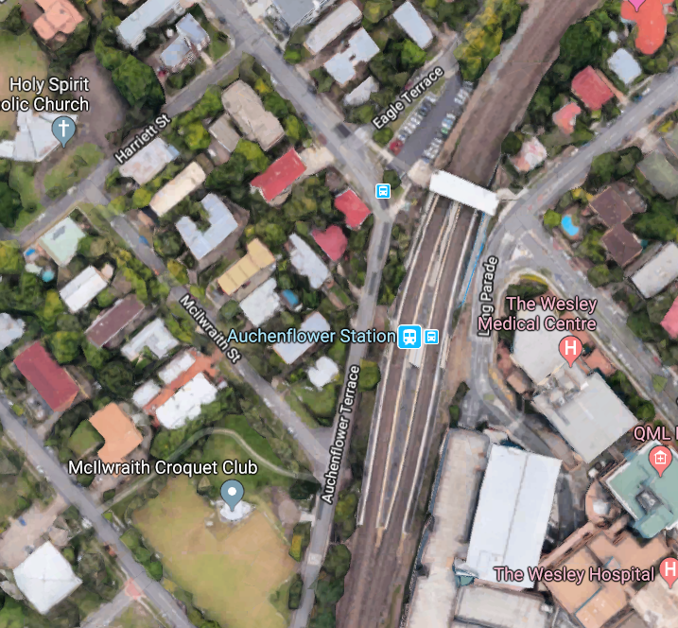

Ridley Street

Lang Parade

ROAD CLOSED
LANE CONTROL

PLATFORM 1
PLATFORM 4

Traffic diversion

Road closure – Auchenflower Terrace

Lane closure/traffic control – Lang Parade

Map data © Google, 2019

For more information, please contact the project’s community team during business hours on free call 1800 722 203 or email stationsupgrade@qr.com.au

We are moving towards paperless notifications about noise and works. You will still see paper notices as we transition to the new system. Sign up at queenslandrail.com.au/EmailNotification or contact us if you prefer to receive paper copies.

