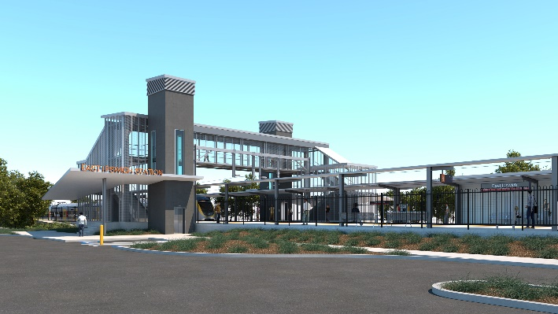
East Ipswich station accessibility upgrade

WORKS NOTICE

After hours works including weekend station closure
11.30pm Friday 11 to 4am Monday 14 June 2021
As part of the East Ipswich station accessibility upgrade, night and weekend works will be undertaken from 11.30pm on Friday 11 to 4am Monday 14 June (weather and construction conditions permitting).
Rail services will not stop at East Ipswich on Saturday 12 and Sunday 13 June. All Ipswich and Rosewood line services will continue as scheduled.
A free shuttle will operate every 30 minutes from Merton Street and Coronation Street to transport customers to and from Ipswich station, providing a connection to scheduled rail services. Please allow at least an additional 30 minutes for travel or consider using an alternative station, if convenient.
The station’s footbridge will remain open for cross-corridor pedestrian traffic. The Coronation/Gibbon Street station entrance will be closed for works all weekend.
For safety of the public and workers, Merton Street will be closed to traffic during works. Access to private properties will be maintained at the instruction of the traffic controller.
Nearby residents may experience noise associated with construction activity and truck movements. Mobile lighting towers will be used during night works.
Queensland Rail Limited ABN 71 132 181 090

Scheduled works
Location | Dates and hours of work | Type of work
East Ipswich station precinct  Coronation Street entrance – closed  Footbridge – open  Merton Street – road closed | After hours works:  - 11.30pm Friday 11 to  4am Monday 14 June  (continuous works)  Station closed with no services stopping on Saturday 12 and Sunday 13 June. | Station upgrade works involving:  - platform raising activities  - heavy machinery and trucks with flashing lights and reversing beepers  - hand-held tools and powered equipment  - movement of people and vehicles around the station  - portable lighting in use at night  - road closure and traffic management (Merton Street).

This weekend closure will allow uninterrupted access for platform works without disrupting services on the Ipswich and Rosewood line. These intensive works are an important step towards project completion.
The East Ipswich station accessibility upgrade is part of the State Government’s investment of more than $500 million to upgrade stations across the South East Queensland network, making them accessible for all customers. For more information, please contact the project’s community team on free call 1800 722 203 or email stationsupgrade@qr.com.au

