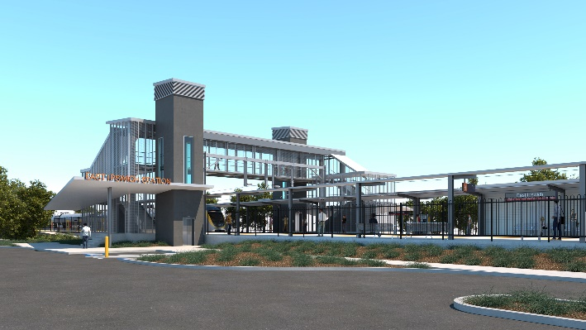
East Ipswich station accessibility upgrade

WORKS NOTICE

After hours works including weekend station closure
11.30pm Friday 27 to 5am Monday 30 November 2020
As part of the East Ipswich station accessibility upgrade, night and weekend works will be undertaken from 11.30pm on Friday 27 to 5am Monday 30 November.
Rail services will not stop at East Ipswich on Saturday 28 and Sunday 29 November. All Ipswich and Rosewood line services will continue as scheduled.
A free shuttle will operate every 30 minutes from Merton Street and Coronation Street to transport customers to and from Ipswich station, providing a connection to scheduled rail services. Please allow at least an additional 30 minutes for travel or consider using an alternative station, if convenient.
This weekend closure will allow uninterrupted access for platform works without disrupting services on the Ipswich and Rosewood line. These intensive works are a critical step towards project completion.
During these works, the station’s footbridge will remain open for cross-corridor pedestrian traffic. The Coronation/Gibbon Street station entrance will be closed for works all weekend.
Residents near the station may experience some noise associated with construction activity and truck movements. Mobile lighting towers will be used during night works.

Scheduled works
Queensland Rail Limited ABN 71 132 181 090
Location | Dates and hours of work | Type of work
East Ipswich station precinct | After hours works:  - 11.30pm Friday 27 to  5am Monday 30 November  (continuous works)  Station closed with no services stopping on Saturday 28 and Sunday 29 December. | Station upgrade works involving:  - piling (drilling) station and platform foundations  - heavy machinery and trucks with flashing lights and reversing beepers  - hand-held tools and powered equipment  - movement of people and vehicles around the station precinct  - portable lighting in use at night.

The East Ipswich station accessibility upgrade is part of State Government’s investment to upgrade stations across the South East Queensland network, making them accessible for all customers. For more information, please contact the project’s community team on free call 1800 722 203 or email stationsupgrade@qr.com.au

