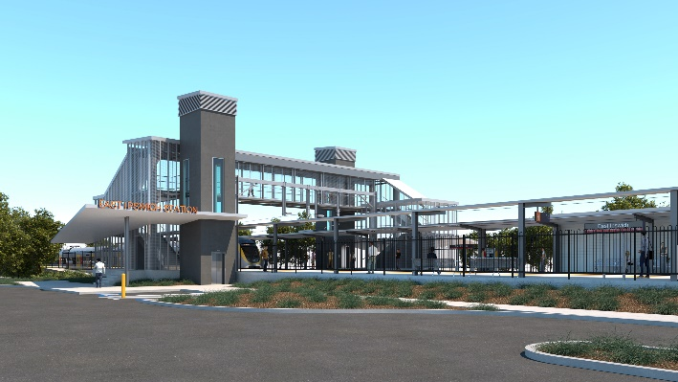
East Ipswich station accessibility upgrade

WORKS NOTICE

Temporary road closures

- Monday 8 and Tuesday 9 March 2021 – Merton Street
- Wednesday 10 and Thursday 11 March 2021 – Coronation Street

To enable the safe operation of a large crane at East Ipswich station, Queensland Rail will temporarily close Merton Street on Monday 8 and Tuesday 9 March and Coronation Street on Wednesday 10 and Thursday 11 March, from 7am to 5pm each day.
Access to private property will be maintained at all times. Residents may experience short delays (up to 10 minutes) during critical activities such as crane operation. Motorists and pedestrians are asked to please follow the instructions of the traffic controllers.
Every effort will be made to minimise disruption wherever possible and we apologise for any inconvenience as we undertake these important works.
Note: In the event of adverse weather, works may be rescheduled (without further notification) to the following week – Monday 15 and Tuesday 16 March for Merton Street and Wednesday 17 and Thursday 18 March for Coronation Street.
Overview of road closures
Queensland Rail Limited ABN 71 132 181 090
Location | Dates and hours of work | Type of work
East Ipswich station  - Merton Street (near Woollen Mill Way)  - Coronation Street (between Gibbon and James Streets) | Merton Street closure:  7am to 5pm each day on:  - Monday 8 March  - Tuesday 9 March  (Weather contingency: Monday 15 and Tuesday 16 March – if required)  Coronation Street closure:  7am to 5pm each day on:  - Wednesday 10 March  - Thursday 11 March  (Weather contingency: Wednesday 17 and Thursday 18 March – if required) | Station accessibility upgrade activities involving:  - large crane operation  - movement of personnel and vehicles around the station precinct, rail corridor and surrounding streets  - traffic management (road closures) – Coronation and Merton Streets.
For traffic management enquiries, please contact KPI Construction Services on free call 1800 574 574.
The East Ipswich station accessibility upgrade is part of the State Government’s investment of more than $500 million to upgrade stations across the South East Queensland network, making them accessible for all customers.
For more information about Queensland Rail’s works, please contact the project’s community team on free call 1800 722 203 or email stationsupgrade@qr.com.au

