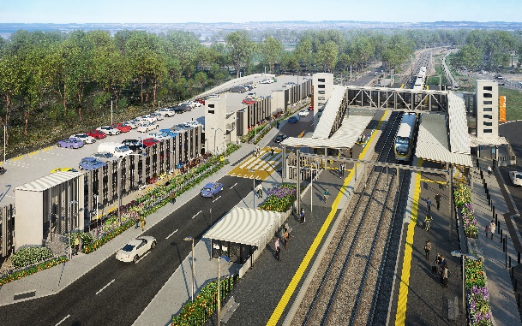
Dakabin station accessibility upgrade

WORKS NOTICE

After hours and weekend works during track closure

8pm Friday 27 to 5am Monday 30 August 2021

As part of the Dakabin station accessibility upgrade, Queensland Rail will undertake continuous (around-the-clock) works from 8pm Friday 27 to 5am Monday 30 August (weather and construction conditions permitting).
These works have been scheduled during a planned track closure when there are no trains operating and fewer customers around the station precinct. Buses will replace trains during this weekend track closure, leaving from the temporary stop on Narangba Road.
Nearby residents may experience some noise associated with construction activities and the operation of cranes and heavy equipment.
For safety, Thompson Road will remain closed to traffic through the station precinct until Thursday 30 September.
Pedestrian access, connecting Alma Road (to the north) and Thompson Road (to the south) will be maintained past the work zone along the Thompson Road footpath. Pedestrian access across the rail corridor via the station footbridge will be maintained.
Every effort will be made to minimise disruption and inconvenience as we work to improve your station.

Overview of weekend works
Location | Dates and hours of work | Type of work
Dakabin station precinct and adjacent rail corridor  Platforms and carparks – closed  Pedestrian (only) access (north-south) – open via Thompson Road footpath  Footbridge – open | 8pm Friday 27 to 5am Monday 30 August  (continuous works) | Station upgrade works involving:  Queensland Rail Limited ABN 71 132 181 090  - paving to new raised platform sections  - resurfacing of asphalt to existing platforms  - removal of contractor’s temporary site offices  - operation of heavy equipment and trucks with flashing lights and reversing beepers  - use of powered tools and hand-held equipment  - movement of personnel and vehicles around the station precinct and rail corridor  - traffic management.
The Dakabin station accessibility upgrade is part of the State Government’s ongoing investment of more than $500 million to upgrade stations across the South East Queensland network, making them accessible for all customers.
For more information about the upgrade, please contact the project’s community team on free call 1800 722 203 or email stationsupgrade@qr.com.au

Sign up for electronic notifications at queenslandrail.com.au/EmailNotification

