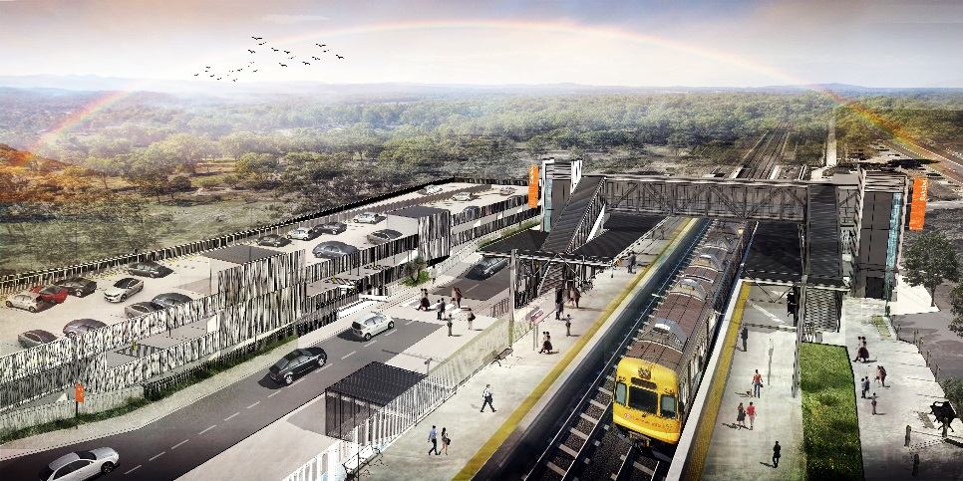
Dakabin station accessibility upgrade

WORKS NOTICE

Weekend works

Saturday 29 and Sunday 30 August 2020

As part of the Dakabin station accessibility upgrade, Queensland Rail will undertake weekend works on Saturday 29 and Sunday 30 August, 6.30am to 6.30pm (weather and construction conditions permitting).
These works have been scheduled during a planned track closure when there are no trains operating and fewer customers around the station precinct. Buses will replace trains during this weekend track closure.
Nearby residents may experience some noise associated with construction activities and the operation of cranes and heavy equipment.
For the safety of workers and the public, traffic management will be in operation on-site. Motorists and pedestrians are requested to observe the changed traffic conditions and follow the instructions of the traffic controller.
Every effort will be made to minimise disruption and inconvenience as we work to improve your station.

Overview of weekend works
Location | Dates and hours of work | Type of work  Queensland Rail Limited ABN 71 132 181 090
Dakabin station precinct and adjacent rail corridor  Carparks – closed  Thompson Road (near station) – disruptions expected with traffic control in place for safety | 6.30am to 6.30pm each day on:  - Saturday 29 August  - Sunday 30 August  (day works only) | Station upgrade works involving:  - Footbridge assembly and installation  - operation of cranes, heavy equipment and trucks with flashing lights and reversing beepers  - use of powered tools and hand-held equipment  - movement of personnel and vehicles around the station precinct and rail corridor  - traffic management.
Novel Coronavirus (COVID-19) – Queensland Rail is committed to keeping essential rail services operating for Queenslanders during this challenging time and to do this, network maintenance and critical capital works must continue. To support workforce safety, Queensland Rail has implemented a number of additional control measures related to COVID-19 management. We will continue to take the necessary precautions to ensure the ongoing health and wellbeing of our team and the communities in which we operate.
The Dakabin station accessibility upgrade is part of Queensland Rail’s $357 million investment to upgrade stations across the South East Queensland network, making them accessible for all customers.
For more information about the upgrade, please contact the project’s community team during business hours on 1800 722 203 (free call) or email stationsupgrade@qr.com.au

Sign up for paperless notifications at queenslandrail.com.au/EmailNotification

