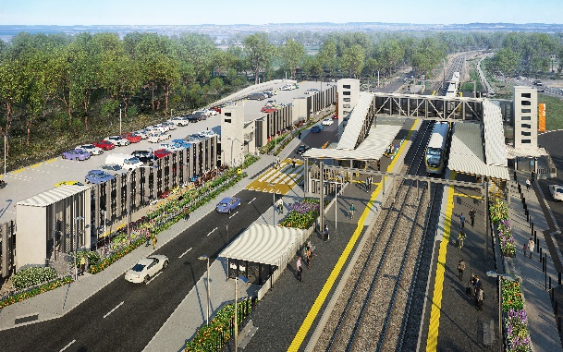
Dakabin station accessibility upgrade

WORKS NOTICE

After hours and weekend works during track closure

6am Saturday 29 to 6am Monday 31 January 2022

As part of the Dakabin station accessibility upgrade, Queensland Rail will undertake continuous (around-the-clock) works from 6am Saturday 29 to 6am Monday 31 January (weather and construction conditions permitting).
These works have been scheduled during a planned track closure when there are no trains operating and fewer customers around the station precinct. Buses will replace trains during this weekend track closure.
Pedestrian access will be maintained along Thompson Road and across the rail corridor via the station footbridge. Please take care around the work zones.
Nearby residents may experience some noise associated with construction activities and the operation of heavy machinery (including concrete saws and rock-breaking equipment).
Every effort will be made to minimise disruption and inconvenience as we work to improve your station.

Overview of weekend works
Location | Dates and hours of work | Type of work
Dakabin station precinct and adjacent rail corridor  Platforms and carparks – closed  Pedestrian access (north-south) – open via Thompson Road  Footbridge – open for cross-corridor pedestrian access | 6am Saturday 29 to 6am Monday 31 January  (continuous works) | Station upgrade works involving:  Queensland Rail Limited ABN 71 132 181 090  - platform works including paving and asphalting  - operation of concrete saw and rock-breaking equipment  - operation of heavy equipment and trucks with flashing lights and reversing beepers  - use of powered tools and hand-held equipment  - activities in preparation for the demobilisation of the project site compound  - movement of personnel and vehicles around the station precinct and rail corridor.
The Dakabin station accessibility upgrade is part of the State Government’s ongoing investment of more than $500 million to upgrade stations across the South East Queensland network, making them accessible for all customers.
For more information about the upgrade, please contact the project’s community team during business hours on 1800 722 203 (free call) or email stationsupgrade@qr.com.au

Sign up for paperless notifications at queenslandrail.com.au/EmailNotification

