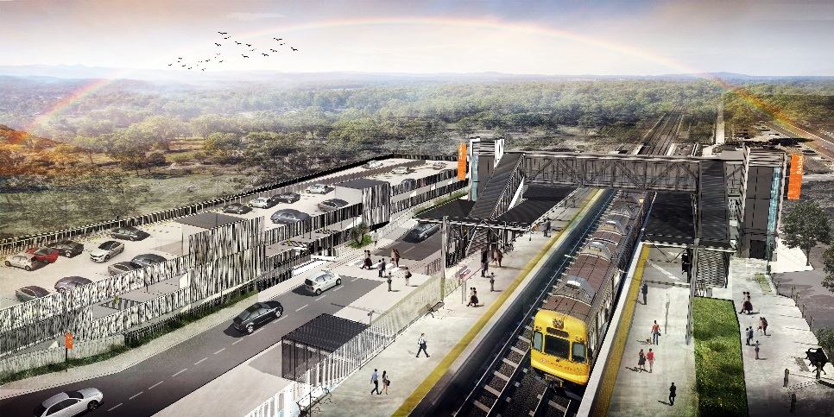
Dakabin station accessibility upgrade

WORKS NOTICE

Weekend works

Saturday 30 and Sunday 31 May 2020

As part of the Dakabin station accessibility upgrade, Queensland Rail will undertake weekend works on Saturday 30 and Sunday 31 May, 6.30am to 6.30pm (weather and construction conditions permitting).
These activities are a continuation of previously notified early works, as well as platform raising activities and the installation of under track services.
Nearby residents may experience some noise associated with construction activities and the operation of heavy machinery. These works have been scheduled during a planned track closure when there are no trains operating and fewer customers around the station precinct.
The community may also see work continuing along Thompson Road, including the ongoing installation of the new water and sewer main.
For the safety of workers and the public, traffic management will be in operation on-site. Motorists and pedestrians are requested to observe the changed traffic conditions and follow the instructions of the traffic controller.
Every effort will be made to minimise disruption and inconvenience as we work to improve your station.

Overview of after hours works
Location | Dates and hours of work | Type of work  Queensland Rail Limited ABN 71 132 181 090
Dakabin station precinct and adjacent rail corridor  Carpark (Narangba Road side) – closed, disruptions expected  Thompson Road (near station) – disruptions expected with traffic control in place for safety | - Saturday 30 and Sunday 31 May, 6.30am to 6.30pm each day | Station upgrade works involving:  - platform works including excavation and construction of the new raised platform sections  - screw piling (drilling) and service installations (water, sewer and electrical)  - operation of cranes, heavy equipment and trucks with flashing lights and reversing beepers  - use of powered tools and hand-held equipment  - movement of personnel and vehicles around the station precinct and rail corridor  - traffic management.
Novel Coronavirus (COVID-19) – Queensland Rail is committed to keeping essential rail services operating for Queenslanders during this challenging time and to do this, network maintenance and critical capital works must continue. To support workforce safety, Queensland Rail has implemented a number of additional control measures related to COVID-19 management. We will continue to take the necessary precautions to ensure the ongoing health and wellbeing of our team and the communities in which we operate.
The Dakabin station accessibility upgrade is part of Queensland Rail’s $357 million investment to upgrade stations across the South East Queensland network, making them accessible for all customers.
For more information about the upgrade, please contact the project’s community team during business hours on 1800 722 203 (free call) or email stationsupgrade@qr.com.au

Sign up for paperless notifications at queenslandrail.com.au/EmailNotification

