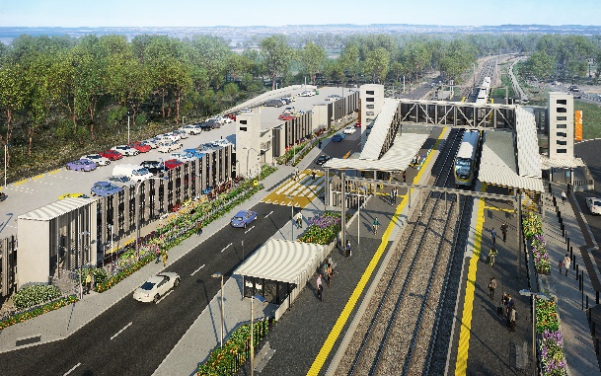
Dakabin station accessibility upgrade

WORKS NOTICE

After hours and weekend works during track closure

11.30pm Friday 4 to 11pm Sunday 6 June 2021

As part of the Dakabin station accessibility upgrade, Queensland Rail will undertake continuous (around-the-clock) works from 11.30pm Friday 4 to 11pm Sunday 6 June (weather and construction conditions permitting).
These works have been scheduled during a planned track closure when there are no trains operating and fewer customers around the station precinct. Buses will replace trains during this weekend track closure.
Nearby residents may experience some noise associated with construction activities and the operation of cranes and heavy equipment.
Pedestrian access, connecting Alma Road (to the north) and Thompson Road (to the south) will be maintained past the work zone along Thompson Road. Pedestrian access across the rail corridor via the station footbridge will be maintained.
Every effort will be made to minimise disruption and inconvenience as we work to improve your station.

Overview of weekend works
Location | Dates and hours of work | Type of work  Queensland Rail Limited ABN 71 132 181 090
Dakabin station precinct and adjacent rail corridor  Platforms and carparks – closed  Pedestrian access (north-south) – open via Thompson Road  Footbridge – open | 11.30pm Friday 4 to 11pm Sunday 6 June  (continuous works) | Station upgrade works involving:  - platform works including excavation and concreting  - operation of heavy equipment and trucks with flashing lights and reversing beepers  - use of powered tools and hand-held equipment  - movement of personnel and vehicles around the station precinct and rail corridor  - traffic management.

The Dakabin station accessibility upgrade is part of the State Government’s ongoing investment of more than $500 million to upgrade stations across the South East Queensland network, making them accessible for all customers.
For more information about the upgrade, please contact the project’s community team during business hours on 1800 722 203 (free call) or email stationsupgrade@qr.com.au

Sign up for paperless notifications at queenslandrail.com.au/EmailNotification

