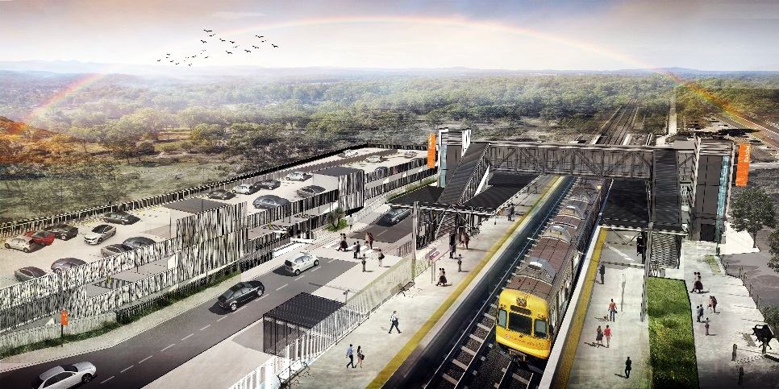
Dakabin station accessibility upgrade

WORKS NOTICE

After hours works – scheduled track closure

February 2020

As part of the Dakabin station accessibility upgrade, Queensland Rail will undertake works from 1am to 7pm each day on Saturday 1 and Sunday 2 February (weather and construction conditions permitting).
Works will involve screw piling (drilling) on the station platforms to prepare foundations for future platform raising.
Nearby residents may experience some noise associated with construction activity and the operation of heavy machinery and the movement of vehicles around the station precinct. (A vacuum excavation truck will be used for underground service location during day shifts the week prior to the scheduled weekend track closure.)
For the safety of workers and to maintain rail services, these works have been programmed during the scheduled weekend track closure on the Sunshine Coast/Caboolture line, when buses will replace trains.
Every effort will be made to minimise disruption and inconvenience as we work to improve your station.

Overview of after hours works
Queensland Rail Limited ABN 71 132 181 090
Location | Dates and hours of work | Type of work
Dakabin station  Carpark (Narangba Road side) – closed  Rail corridor  Thompson Road (traffic control) | - Saturday 1 and Sunday 2 February, 1am to 7pm each day  (during scheduled track closure) | Station upgrade works involving:  - screw piling (drilling) on platforms  - operation of heavy equipment and trucks with flashing lights and reversing beepers  - use of powered tools and hand-held equipment  - movement of personnel and vehicles around the station precinct and rail corridor  - traffic management (Thompson Road).

The Dakabin station accessibility upgrade is part of Queensland Rail’s $357 million investment to upgrade stations across the South East Queensland network, making them accessible for all customers.
For more information about the upgrade, please contact the project’s community team during business hours on 1800 722 203 (free call) or email stationsupgrade@qr.com.au

We are moving towards paperless notifications about noise and works. You will still see paper notices as we transition to the new system. Sign up at queenslandrail.com.au/EmailNotification or contact us if you prefer to receive paper copies.

