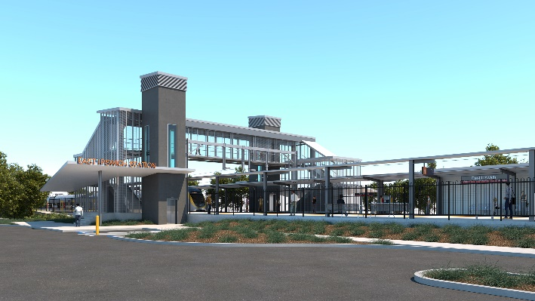
East Ipswich station accessibility upgrade

WORKS NOTICE

Weekend works

11pm Friday 15 to 5am Monday 18 January 2021

As part of the East Ipswich station accessibility upgrade, Queensland Rail will undertake continuous weekend works from 11pm Friday 15 until 5am Monday 18 January 2021 (weather and construction conditions permitting).
These works have been planned during a scheduled closure of the Ipswich/Rosewood line when buses will replace trains.
Every effort will be made to minimise disturbance wherever possible. We apologise for any inconvenience and appreciate your patience as we undertake these important works.
Overview of works
Queensland Rail Limited ABN 71 132 181 090
Location | Dates and hours of work | Type of work
East Ipswich station precinct and rail corridor  Main station carpark (closed)  Rail corridor access gates:  - Merton Street  - Coronation Street  - Irvine Street  - Bunya Street | 11pm Friday 15 to 5am Monday 18 January 2021  (continuous, around-the-clock works) | Station upgrade works involving:  - platform works  - concreting  - installation of structural steel work  - use of hand-held equipment and powered tools (eg. powered socket wrench or ‘rattle gun’)  - excavation, earthworks and construction of retaining walls  - operation of heavy equipment, on-track vehicles and trucks with flashing lights and reversing beepers  - launching on-track vehicles into the rail corridor via access gates (Irvine and Bunya Streets)  - movement of personnel and vehicles around the station precinct and rail corridor  - traffic management – Coronation and Merton Streets  - use of lighting towers at night.

The East Ipswich station accessibility upgrade is part of the State Government’s ongoing investment of more than $500 million to upgrade stations across the South East Queensland network, making them accessible for all customers.
For more information, please contact the project’s community team on free call 1800 722 203 or email stationsupgrade@qr.com.au

