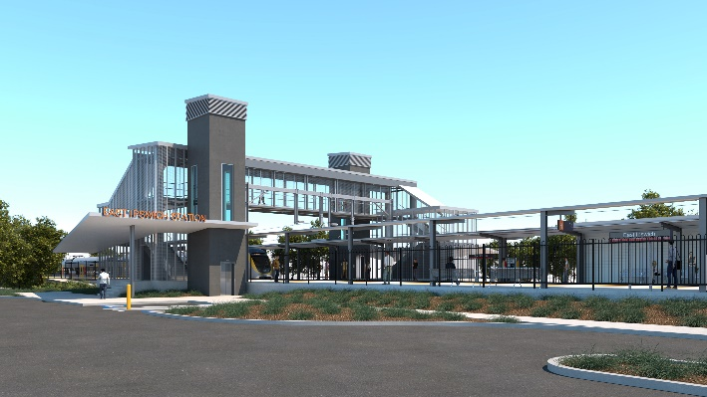
East Ipswich station accessibility upgrade

WORKS NOTICE

Weekend and night works

July 2021

As part of the East Ipswich station accessibility upgrade, Queensland Rail will undertake continuous weekend works from 8pm Friday 16 until 5am Monday 19 July 2021 (weather and construction conditions permitting). These works have been planned during a scheduled closure of the Ipswich/Rosewood line when buses will replace trains. A road closure will be in place at the corner of Coronation and Gibbon Streets.
Following these weekend works, overnight works will be undertaken from 8pm until 6am the next day on selected nights between Monday 19 and Wednesday 28 July 2021.
Every effort will be made to minimise disturbance wherever possible. We apologise for any inconvenience and appreciate your patience as we undertake these important woks.
Overview of works
Queensland Rail Limited ABN 71 132 181 090
Location | Dates and hours of work | Type of work
East Ipswich station precinct and rail corridor  Main station carpark (closed)  Rail corridor access gates:  - Merton Street  - Coronation Street | Weekend works during track closure:  8pm Friday 16 to 5am Monday 19 July  (continuous, around-the-clock works)  Night works:  8pm to 6am the next day on:  - Monday 19 July  - Tuesday 20 July  - Monday 26 July  - Tuesday 27 July  - Wednesday 28 July  (over five separate nights) | Station upgrade works involving:  - concrete pours  - platform works  - paving, tiling and painting  - use of hand-held equipment and powered tools  - operation of heavy equipment and trucks with flashing lights and reversing beepers  - movement of personnel and vehicles around the station precinct and rail corridor  - traffic management – Coronation and Merton Streets  - road closure with traffic management – Coronation Street/Gibbon Street  - use of lighting towers at night.
The East Ipswich station accessibility upgrade is part of the State Government’s ongoing investment of more than $500 million to upgrade stations across the South East Queensland network, making them accessible for all customers. For more information, please contact the project’s community team on free call 1800 722 203 or email stationsupgrade@qr.com.au
