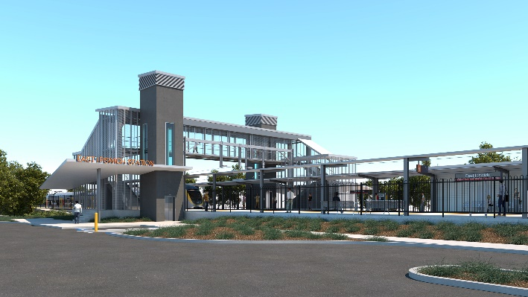
East Ipswich station accessibility upgrade

WORKS NOTICE

Weekend and night works

11pm Friday 7 to 5am Tuesday 11 May 2021

As part of the East Ipswich station accessibility upgrade, Queensland Rail will undertake continuous weekend works from 11pm Friday 7 until 5am Monday 10 May 2021 (weather and construction conditions permitting). These works have been planned during a scheduled closure of the Ipswich/Rosewood line when buses will replace trains.
Following these weekend works and only if required, overnight works will be undertaken on Monday 10 May 2021 from 6pm until 5am the next day.
Every effort will be made to minimise disturbance wherever possible. We apologise for any inconvenience and appreciate your patience as we undertake these important woks.
Overview of works
Queensland Rail Limited ABN 71 132 181 090
Location | Dates and hours of work | Type of work
East Ipswich station precinct and rail corridor  Main station carpark (closed)  Rail corridor access gates:  - Merton Street  - Coronation Street | Weekend works during track closure:  11pm Friday 7 to 5am Monday 10 May 2021  (continuous, around-the-clock works)  Night works (only if required):  Monday 10 May 2021, 6pm to 5am the next day  (overnight works) | Station upgrade works involving:  - operation of a large crane to lift the new station footbridge into place  - platform works and concreting  - installation of structural steel work, including heritage shelter  - use of hand-held equipment and powered tools (eg. powered socket wrench or ‘rattle gun’)  - excavation and earthworks  - operation of heavy equipment and trucks with flashing lights and reversing beepers  - movement of personnel and vehicles around the station precinct and rail corridor  - traffic management – Coronation and Merton Streets  - use of lighting towers at night.
The East Ipswich station accessibility upgrade is part of the State Government’s ongoing investment of more than $500 million to upgrade stations across the South East Queensland network, making them accessible for all customers.
For more information, please contact the project’s community team on free call 1800 722 203 or email stationsupgrade@qr.com.au

