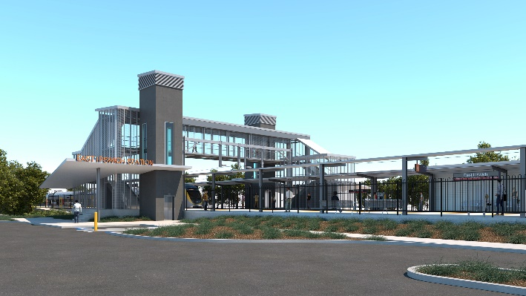
East Ipswich station accessibility upgrade

WORKS NOTICE

Merton Street site office relocation

From Friday 20 August 2021

To support the next phase of station upgrade works, the project’s site offices are relocating to a new temporary location on Ipswich Vigoro Association land (identified by the green area on the map below). Site office buildings have been delivered and the new compound will be operational from Friday 20 August.
The project contractor explored a number of relocation options, with this solution considered the most viable, with access to services such as water, sewer and power. Queensland Rail is committed to minimising impacts to residents and we thank you for your continued patience and cooperation as we work toward project completion.
Pedestrian access to the new office location will be via Joyce Street (see below). Workers will move between the site offices and work zone via a direct link into the rail corridor.
Vehicle access to the site office will be via the property’s gate in Joyce Street. Worker parking will be provided in the main station carpark, with informal street parking in Woollen Mill Way. Workers will be instructed not to park in Joyce Street or Merton Street. Project vehicles (eg. excavators , concrete trucks) will continue to enter the work zone from Merton Street (see below).
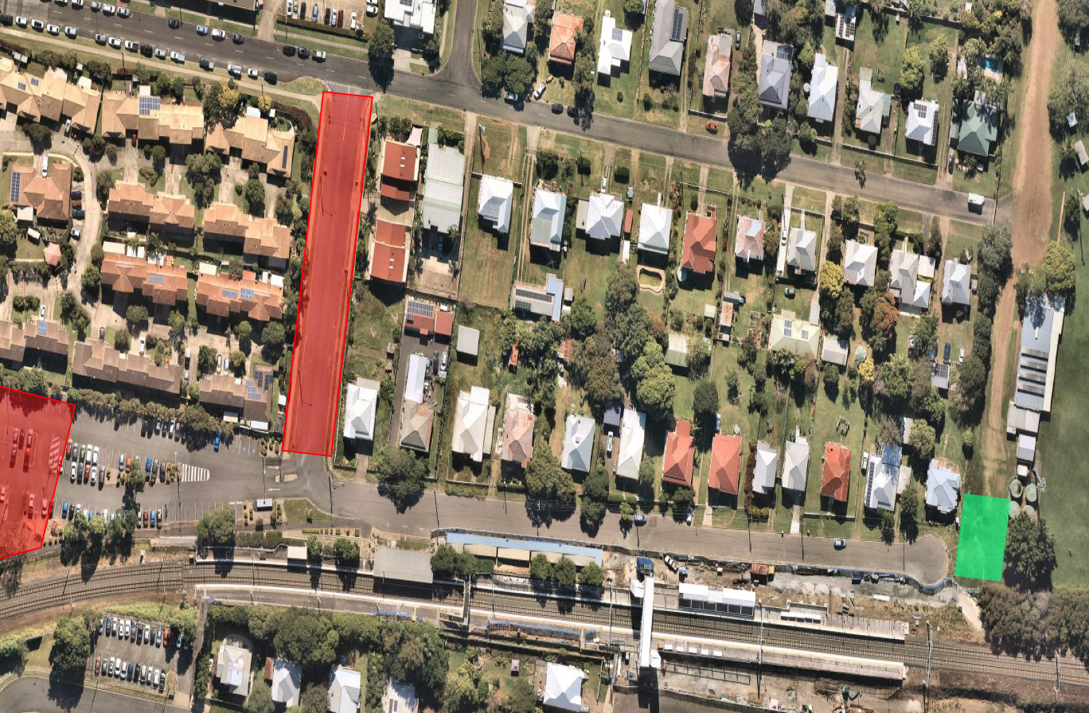
Map data © Google, 2021
JOYCE STREET
Site office vehicle entry
Worker pedestrian access

Worker parking

MERTON STREET

WORK ZONE

Relocated site offices

Construction of the new station is expected to be completed in late 2021. Supporting works, including the demolition of the old station building and platforms, will continue into 2022. Normal working hours are 6.30am to 6.30pm, Monday to Saturday. For more information, please contact the project’s community team on free call 1800 722 203 or email stationsupgrade@qr.com.au

Sign up for electronic notifications at queenslandrail.com.au/EmailNotification

