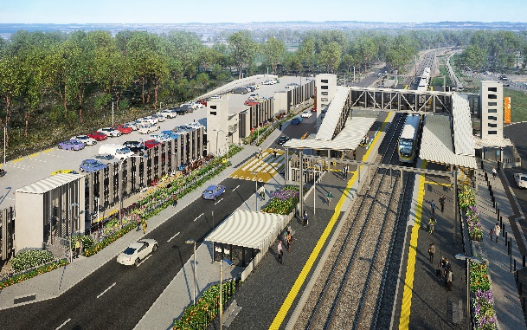
Dakabin station accessibility upgrade

WORKS NOTICE

Weekend works

Sunday 7 November 2021

As part of the Dakabin station accessibility upgrade, Queensland Rail will undertake cable installation throughout the precinct on Sunday 7 November (6.30am to 6.30pm), weather and construction conditions permitting.
These weekend works are part of the program of cable installation during regular daytime shifts from 4 to 12 November.
Nearby residents may experience noise associated with activities on-site, as well as the operation of vehicles and equipment.
For safety, Thompson Road will remain closed to traffic through the station precinct until Tuesday 30 November.
Pedestrian access, connecting Alma Road (to the north) and Thompson Road (to the south) will be maintained. The station will continue to operate as usual and pedestrian access across the rail corridor will be available via the station footbridge.
Every effort will be made to minimise disruption and inconvenience as we work to improve your station.

Overview of weekend works
Location | Dates and hours of work | Type of work
Dakabin station precinct and adjacent rail corridor  (Station operational) | Sunday 7 November 2021, 6.30am to 6.30pm  (Sunday works, day shift) | Station upgrade works involving:  Queensland Rail Limited ABN 71 132 181 090  - cable installation throughout the precinct (station, carpark, work zones and site compound)  - use of powered tools and hand-held equipment  - operation of vehicles with flashing lights and reversing beepers  - movement of personnel and vehicles around the station precinct and rail corridor.
The Dakabin station accessibility upgrade is part of the State Government’s ongoing investment of more than $500 million to upgrade stations across the South East Queensland network, making them accessible for all customers.
For more information, please contact the project’s community team on free call 1800 722 203 or email stationsupgrade@qr.com.au

Sign up for electronic notifications at queenslandrail.com.au/EmailNotification

