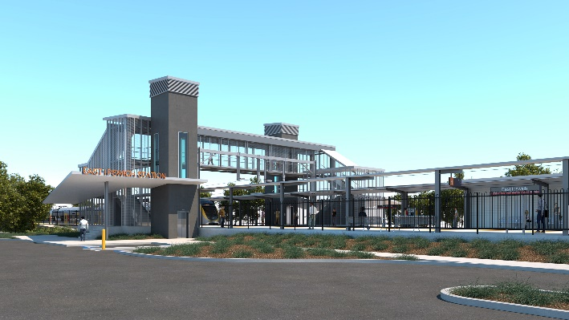
East Ipswich station accessibility upgrade

WORKS NOTICE

After hours (Sunday) works

Sunday 25 October 2020

As part of the East Ipswich station accessibility upgrade, Queensland Rail will undertake after hours foundation piling, overhead infrastructure and demolition works from 6am to 5pm on Sunday 25 October 2020 (weather and construction conditions permitting).
While nearby residents may experience some noise associated with these activities in the vicinity of the work zone, every effort will be made to minimise disruption and we apologise for any inconvenience as we undertake these important works.
Overview of after hours works
Location | Dates and hours of work | Type of work
East Ipswich station precinct (including carparks and rail corridor)  Rail corridor access gates:  - Merton Street, East Ipswich  - Irvine and Bunya Streets, East Ipswich | 6am to 5pm on:  - Sunday 25 October  (day shift only) | Piling, overhead infrastructure and demolition works involving:  - screw piling (drilling) foundations  - adjustments to overhead infrastructure  - concrete/rock breaking  Queensland Rail Limited ABN 71 132 181 090  - use of jackhammers, power tools and hand-held equipment  - operation of on-track vehicles and trucks with bright flashing lights and reversing beepers  - movement of personnel and vehicles around the station precinct, rail corridor and project compound  - launching of on-track vehicles (access gate near Irvine and Bunya Streets)  - traffic management (Merton and Coronation Streets).
The East Ipswich station accessibility upgrade is part of Queensland Rail’s program to upgrade stations across the South East Queensland network, making them accessible for all customers.
For more information, please contact the project’s community team on free call 1800 722 203 or email stationsupgrade@qr.com.au

