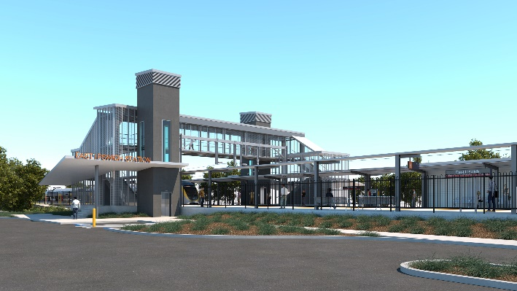
East Ipswich station accessibility upgrade

WORKS NOTICE

Day works – gas main installation

From Monday 19 October 2020

To facilitate station upgrade works, gas provider APA will undertake horizontal directional drilling (underboring) works to install a replacement gas main beneath the rail corridor (between James Street and Merton Street) from Monday 19 October 2020 (day works only for up to three days, weather and construction conditions permitting).
The drilling rig will be set up and launched from the park area at the corner of James and Coronation Streets. A vacuum excavation truck will operate from the end of the cul de sac, near 13 Merton Street.
Traffic management will be in operation on James, Coronation and Merton Streets. Access to private properties will be maintained.
While nearby residents may experience some noise associated with these activities in the vicinity of the work zones, every effort will be made to minimise disruption and we apologise for any inconvenience.
Overview of works
Queensland Rail Limited ABN 71 132 181 090
Location | Dates and hours of work | Type of work
East Ipswich station precinct (project compound, work zones and rail corridor)  Park area at the corner of James and Coronation Streets  Merton Street cul de sac (near 13 Merton Street) | 6.30am to 6.30pm (day shifts only) on:  - Monday 19 October  - Tuesday 20 October  - Wednesday 21 October (if required) | Gas main sleeve pipeline installation (underboring) involving:  - operation of a directional drilling rig  - excavation using vacuum truck  - use of power tools and hand-held equipment  Queensland Rail Limited ABN 71 132 181 090  - operation of trucks and project vehicles with flashing lights and reversing beepers  - movement of personnel and vehicles around the station precinct and work zones  - traffic management (Merton Street and James/Coronation Streets).
The East Ipswich station accessibility upgrade is part of Queensland Rail’s program to upgrade stations across the South East Queensland network, making them accessible for all customers.
For more information, please contact the project’s community team on free call 1800 722 203 or email stationsupgrade@qr.com.au

