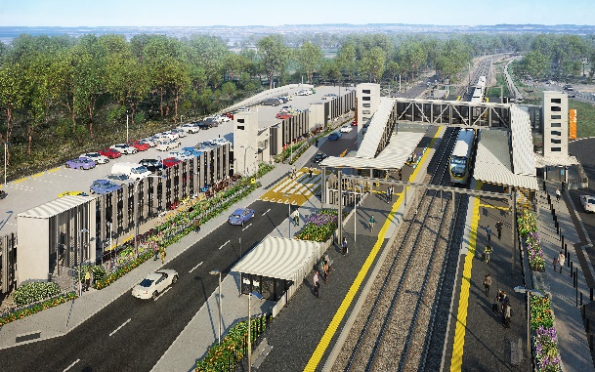
Dakabin station accessibility upgrade

WORKS NOTICE

Weekend works

Saturday 2 and Sunday 3 April 2022

As part of the Dakabin station accessibility upgrade, Queensland Rail will undertake minor platform rectification works on Saturday 2 and Sunday 3 April (6am to 6pm), weather and construction conditions permitting. Some activities may be carried out after hours, if required.
During the weekend track closure buses will replace trains. While the platforms will be closed to the public, pedestrian access across the rail corridor will be available via the station lifts and footbridge.
Nearby residents may experience noise associated with activities on-site, as well as the operation of vehicles and equipment.
Every effort will be made to minimise disruption and inconvenience as we work to improve your station.

Overview of weekend works
Location | Dates and hours of work | Type of work
Dakabin station precinct – platforms  (Footbridge and lifts open) | 6am to 6pm on:  Saturday 2 and Sunday 3 April 2022  (Generally day shifts only, some after hours activities if required) | Station upgrade platform works involving:  Queensland Rail Limited ABN 71 132 181 090  - minor rectification activities  - paving  - staircase maintenance  - use of powered tools and hand-held equipment  - operation of vehicles with flashing lights and reversing beepers  - movement of personnel and vehicles around the station precinct and rail corridor.

The Dakabin station accessibility upgrade is part of the State Government’s ongoing investment of more than $500 million to upgrade stations across the South East Queensland network, making them accessible for all customers.
For more information, please contact the project’s community team on free call 1800 722 203 or email stationsupgrade@qr.com.au

Sign up for electronic notifications at queenslandrail.com.au/EmailNotification

