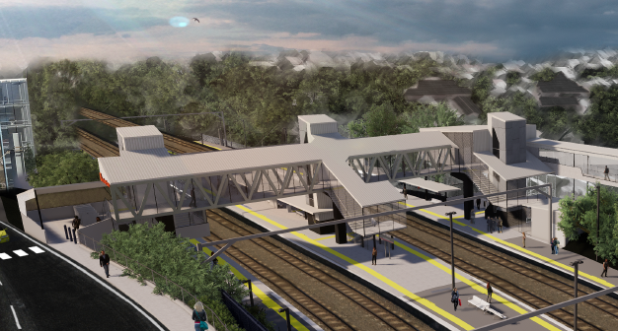
Auchenflower station accessibility upgrade

WORKS NOTICE

Night works and lane closures – overhead line infrastructure
Sunday 1 and Monday 2 December 2019

In preparation for the Auchenflower station accessibility upgrade, Queensland Rail will install overhead line infrastructure over two nights on Sunday 1 and Monday 2 December, each night between 11pm and 4am the next day (weather and construction conditions permitting). For the safety of workers and the public, these works have been scheduled after hours, when there is reduced rail traffic. This is a continuation of the work previously notified for 19 and 20 November.
A lane closure with traffic management (see map over the page) will also be in operation on:
- Sunday 1 December (midnight to 4am), Auchenflower Terrace (between Eagle Terrace and Dixon Street). Local access will be maintained at the instruction of the traffic controller.
- Monday 2 December (midnight to 4am), Lang Parade. Access to The Wesley Hospital precinct will be maintained at the instruction of the traffic controller.
Residents near the station may experience some noise associated with construction activity and the operation of trucks, on-track vehicles and equipment around the work zone. Every effort will be made to minimise disruption and we apologise for any inconvenience as we undertake these important early works.

Overview of night works
Queensland Rail Limited ABN 71 132 181 090
Location | Dates and hours of work | Type of work
Auchenflower station, carpark and rail corridor  Auchenflower Terrace  Lang Parade  Rail corridor access gates (near Dixon Street and Eagle Terrace/Cue Street) | From 11pm to 4am on Sunday 1 and Monday 2 December  (over 2 nights)  Lane closures:  - Auchenflower Terrace – Sunday 1 December, midnight to 4am  - Lang Parade – Monday 2 December, midnight to 4am | Overhead infrastructure works involving:  - installation of steel masts and equipment  - operation of cranes, trucks, on-track vehicles and machinery with flashing lights and reversing beepers  - hand-held tools and powered equipment  - movement of personnel and vehicles around the station and in the rail corridor  - lane closures with traffic management  - portable lighting towers in use at night.
The Auchenflower station accessibility upgrade is part of the State Government’s $357 million program to upgrade stations across the South East Queensland network, making them accessible for all customers.
For more information, please contact the project’s community team on free call 1800 722 203 or email stationsupgrade@qr.com.au

We are moving towards paperless notifications about noise and works. You will still see paper notices as we transition to the new system. Sign up at queenslandrail.com.au/EmailNotification or contact us if you prefer to receive paper copies.

Page 2

Lane closures and traffic management
Auchenflower Terrace and Lang Parade, Auchenflower
- Auchenflower Terrace – Sunday 1 December, midnight to 4am the next day (Monday morning)
- Lang Parade – Monday 2 December, midnight to 4am the next day (Tuesday morning)

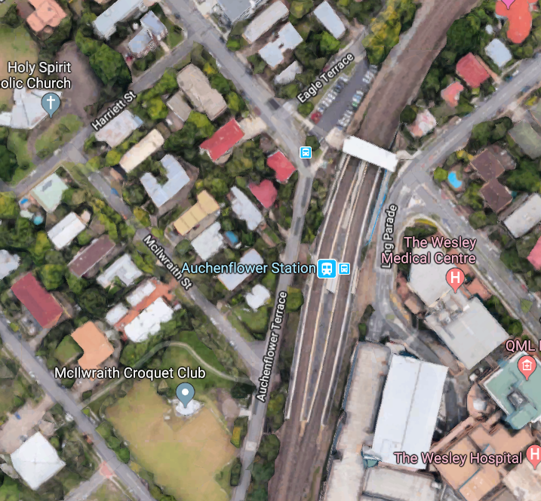

Ridley Street

Lang Parade

LANE CONTROL – 1 DEC
LANE CONTROL – 2 DEC

SUN 1 DEC

Lane closure/traffic control – Auchenflower Terrace

Lane closure/traffic control – Lang Parade

MON 2 DEC

Map data © Google, 2019

For more information, please contact the project’s community team on free call 1800 722 203 or email stationsupgrade@qr.com.au

We are moving towards paperless notifications about noise and works. You will still see paper notices as we transition to the new system. Sign up at queenslandrail.com.au/EmailNotification or contact us if you prefer to receive paper copies.

