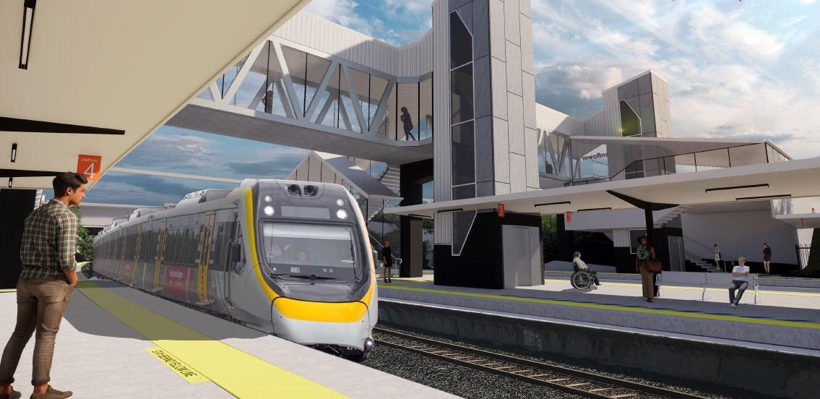Queensland Rail is striving to become a modern, customer-focused rail service and is investing $300 million to upgrade stations, making them accessible for all customers.
Concept design – subject to change
NGR image – photography by Dean Stalker
PROJECT UPDATE MARCH 2019
Auchenflower station accessibility upgrade

As part of the Station Accessibility Upgrade Program, Queensland Rail is making improvements to Auchenflower station.
These improvements include:
- a new pedestrian footbridge with lift access
- raised section of platform at assisted boarding points
- upgraded tactiles and hearing augmentation loops
The concept design is now available and we are seeking your input. We are committed to keeping customers, local residents and community groups informed as the project progresses.
The next step will be to call for tenders for a contractor to undertake detailed design and construction for the project.
For further information about the Auchenflower station accessibility upgrade or to provide feedback:

- upgraded security cameras and station lighting
- new wayfinding and platform signage.
Phone: Email: Post: Website:
1800 722 203 (free call)

stationsupgrade@qr.com.au
GPO Box 1429, Brisbane, QLD 4000 queenslandrail.com.au

Delivery of Queensland Rail’s $300 million Station Accessibility Upgrade Program will mean about 83% of customers will travel to or from an accessible station.

Nambour
Completed Apr 2017
Dinmore
Completed Jun 2017
Graceville
Completed Sep 2017
Newmarket
Completed Nov 2017
Alderley
Completed Nov 2017
Strathpine
Early works commenced late 2017
Morayfield
Early works commenced late 2017
Boondall
Early works commenced early 2018

Albion | Fairfield | Auchenflower | Loganlea | Cannon Hill | Buranda | East Ipswich | Dakabin
Design stage | Design stage | Design stage | Design stage | Design stage | Design stage | Design stage | Design stage

