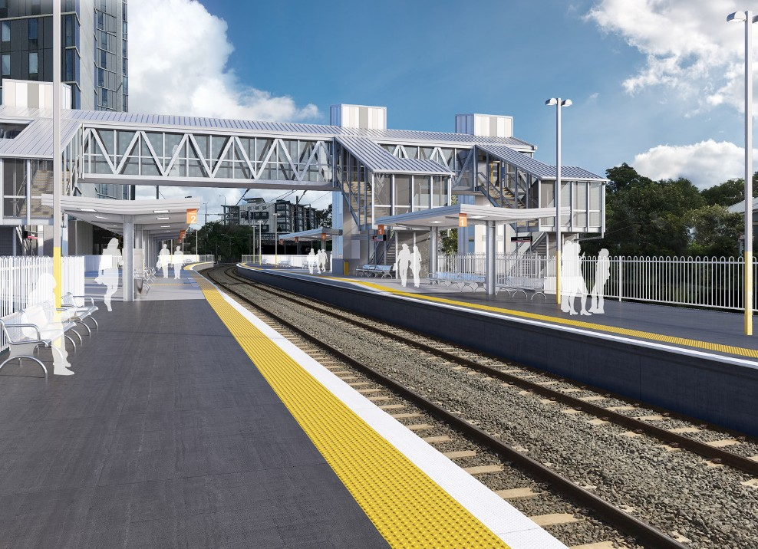Queensland Rail is striving to become a modern, customer-focused rail service and is investing $300 million to upgrade stations, making them accessible for all customers.
BURANDA STATION
Station Accessibility Upgrade Program
PROJECT UPDATE

As part of the Station Accessibility Upgrade Program, Queensland Rail is making improvements to Buranda station.
These improvements include:
- a new pedestrian footbridge with lift access
- raised section of platform at assisted boarding points
The project is currently in the design phase. As we move through the design and construction phases, we will ensure we keep local residents, customers and community groups well informed of the project’s progress.
Artist’s impressions are now available and detailed design is getting underway. For further information or to provide feedback:

- upgraded tactiles and hearing augmentation
Phone:
1800 722 203 (free call)

loops
- upgraded lighting

security cameras and station
Email: Post:

stationsupgrade@qr.com.au
GPO Box 1429, Brisbane, QLD 4000

- new wayfinding and platform signage.
Website:

queenslandrail.com.au

Delivery of Queensland Rail’s $300 million Station Accessibility Upgrade Program will mean about 83% of customers will travel to or from an accessible station.

Nambour
Completed Apr 2017
Dinmore
Completed Jun 2017
Graceville
Completed Sep 2017
Newmarket
Completed Nov 2017
Alderley
Completed Nov 2017
Strathpine
Early works commenced late 2017
Morayfield
Early works commenced late 2017
Boondall
Early works commenced early 2018

Albion | Fairfield | Auchenflower | Loganlea | Cannon Hill | Buranda | East Ipswich | Dakabin
Design stage | Design stage | Design stage | Design stage | Design stage | Design stage | Design stage | Design stage

