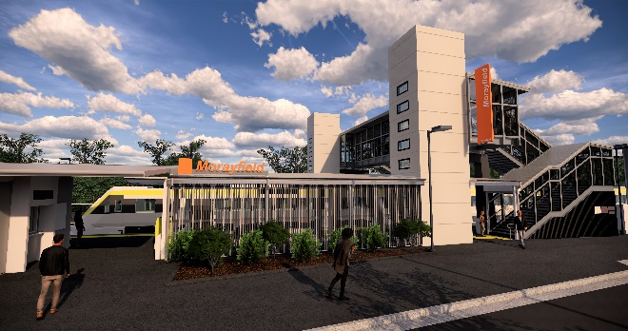
Morayfield station accessibility upgrade

WORKS NOTICE

After hours works including weekend station closure

Early February 2020

As part of the Morayfield station accessibility upgrade, night and weekend works will be undertaken on selected dates in early February, including a weekend station closure on Saturday 8 and Sunday 9 February with no rail services stopping at Morayfield. All Caboolture and Sunshine Coast line services will continue as scheduled.
A free shuttle will operate every 15 minutes to transport customers to and from Caboolture station, providing a connection to scheduled rail services. Customers departing Morayfield to travel north of Caboolture should see station staff for travel assistance. Please allow at least an additional 30 minutes for travel, alternatively you may consider using Caboolture or Burpengary stations if convenient.
This weekend closure will allow uninterrupted access for platform works without disrupting services on the Caboolture and Sunshine Coast line. These intensive works are a critical step towards project completion.
Residents near the station may experience some noise associated with construction activity and truck movements. Mobile lighting towers will be used during night works.
For the safety of the public, there will be no access to the station, footbridge or carparks during the weekend closure.

Scheduled work
Location | Dates and hours of work | Type of work
Morayfield station  Platforms and facilities (closed)  Footbridge (closed) | Night/weekend works associated with the station closure:  - 11.30pm Friday 7 to  6pm Saturday 8 February  - Sunday 9 February, 6am to 10pm  Night works:  - Monday 10 February,  11pm to 4am the next day | Station upgrade and platform works involving:  - paving, fencing and painting  - asphalting  - heavy machinery and trucks with flashing lights and reversing beepers  - hand-held tools and powered equipment  - movement of people and vehicles around the station precinct  - portable lighting in use at night.

Every effort will be made to minimise disruption and we apologise for any inconvenience as we work to improve your station.
The Morayfield station accessibility upgrade is part of the State Government’s $357 million investment to upgrade stations across the South East Queensland network, making them accessible for all customers.
For more information about the accessibility upgrade, please contact the project’s community team on free call 1800 722 203 or email stationsupgrade@qr.com.au

We are moving towards paperless notifications about noise and works. You will still see paper notices as we transition to the new system. Sign up at queenslandrail.com.au/EmailNotification or contact us if you prefer to receive paper copies.

