**Timber rail bridge replacement program – Kavanagh Street East, Thagoona**

**Queensland Rail is replacing a series of rail bridges on the Ipswich to Rosewood line, in South East Queensland, to deliver a safer and more reliable network.**

Under this program, ageing timber bridges will be replaced with steel and concrete structures which better maintain bridge safety and function over time.

The first bridge to be replaced is at Kavanagh Street East, Thagoona.

Construction is planned to begin in the first half of 2015 to allow Queensland Rail to coordinate its works with Ipswich City Council’s flood mitigation works program.

Queensland Rail is working closely with Council, using its hydrology modelling to inform the design and construction for five replacement timber bridges in this area.

**What is involved?**

The Kavanagh Street East bridge will be constructed on the existing alignment.

The new structure will comprise three 10m spans, which will widen the opening under the bridge and increase the water flow area.

The new structure will consist of eight bored piles supporting a concrete, ballasted bridge deck. The current height clearance of 4m will be maintained.

The existing timber bridge will remain in service during construction but will be removed on completion of the new bridge.

**Safety is our priority**

Safety is the number one priority for Queensland Rail.

In order to provide a safe work environment for workers and the community, public access to areas near the construction site will be restricted during works.

**Construction impacts**

Queensland Rail is currently engaging with potentially affected residents and nearby stakeholders to understand the project impacts and minimise disruption to the community during construction.

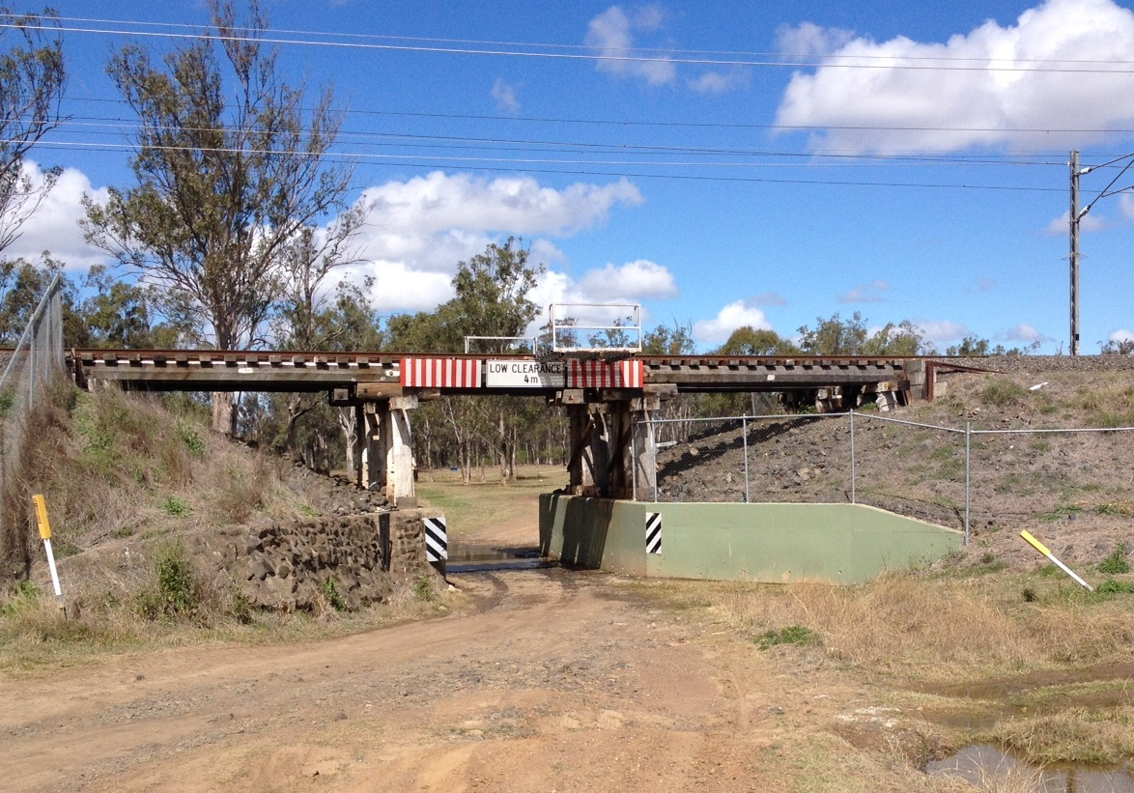

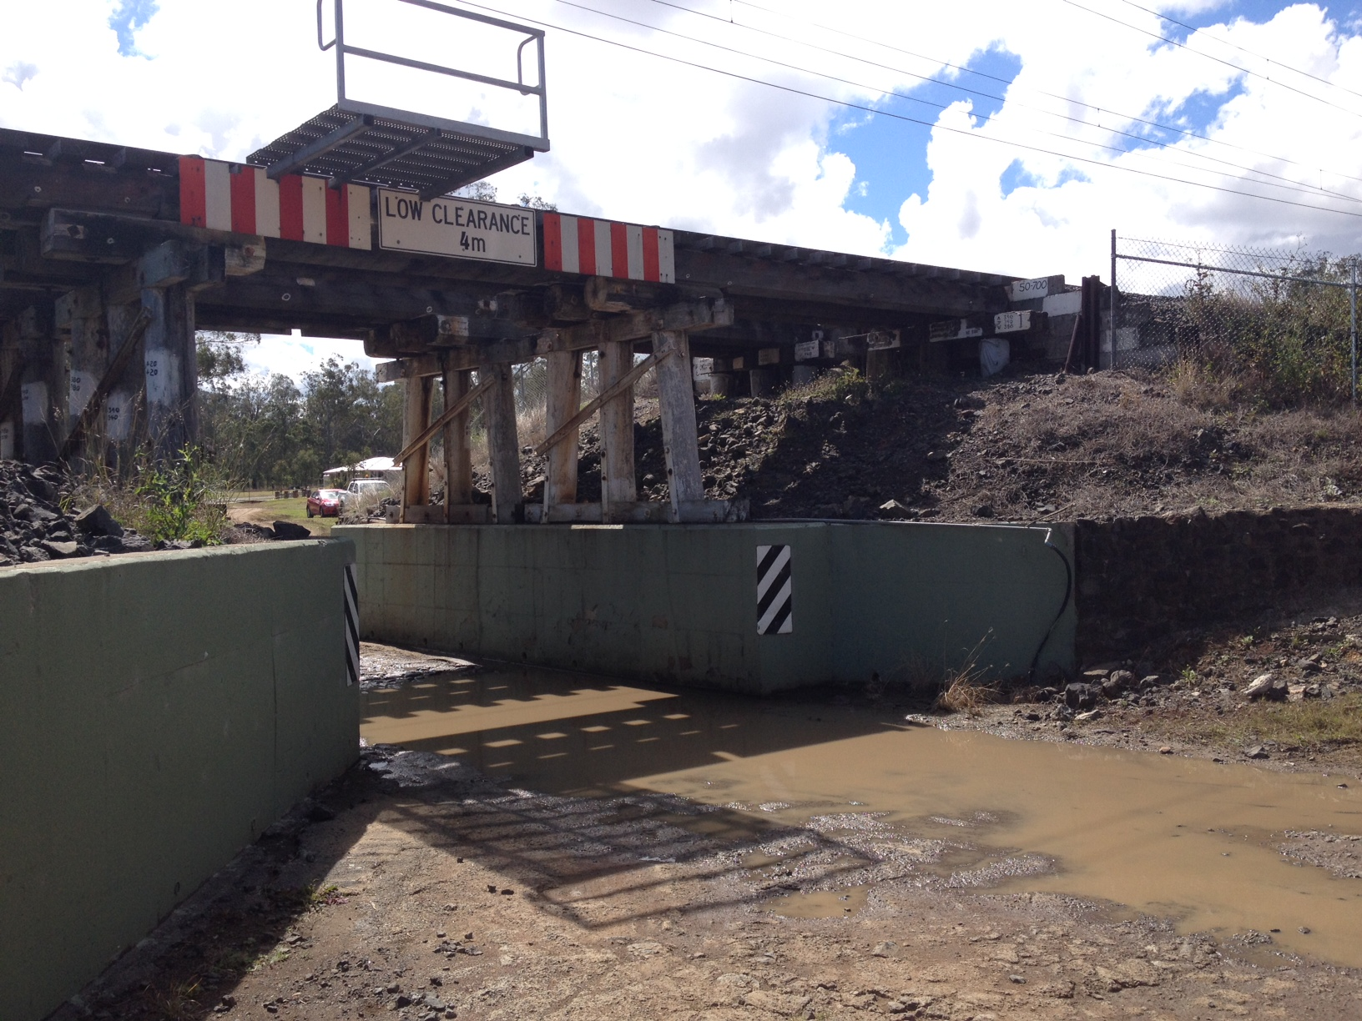

The local community may notice increased vehicle movements around the work zone, including delivery of plant and equipment.

The construction impacts for nearby residents may include access, night works, vehicle movements and noise, such as reversing beepers, piling works and materials delivery.

Construction will be scheduled to minimise passenger timetable disruption. The final bridge installation will be scheduled to occur over a 48-hour period, with a temporary closure of the rail line and around the clock construction works. The old timber bridge will be removed at this time.

Residents will be given advance notification of periods of heightened activity, temporary property access restrictions, excessive noise or night works, in accordance with Queensland Rail’s community engagement guidelines.

Queensland Rail apologises for any inconvenience and thanks stakeholders and the local community for their cooperation during these important works.

**Other bridge replacements**

Five timber rail bridges in the City of Ipswich – all between 100 and 150 years old – will be upgraded or replaced as part of this program. The other bridges are at:

* Karrabin – replacement
* Guilfoyles Gully, Walloon – replacement
* Rosewood – replacement
* Sadliers Crossing – upgrade.

Queensland Rail investigated a range of possible bridge replacement options for each location. Investigations considered hydrology modelling, bridge height clearances and constructability issues.

Where possible, the overall program schedule will be planned to deliver works simultaneously at multiple sites for greater efficiency, to minimise line closures and to reduce impacts on the community.

The program to replace all five bridges is scheduled to be completed by mid-2017, weather and construction conditions permitting.

**Keeping you informed**

Queensland Rail is committed to keeping stakeholders and the community informed about the Kavanagh Street East, Thagoona timber bridge replacement.

For more information about this project or the other planned bridge replacements on the Ipswich to Rosewood line, telephone 1800 645 836 seven days or 13 16 17 between 7.15am and 5pm Monday to Friday, or email communityengagement@qr.com.au.