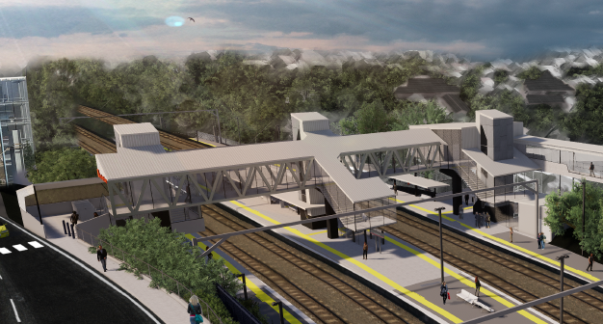

**Auchenflower station accessibility upgrade**

**PROJECT UPDATE – AUGUST 2020**

**The Auchenflower station accessibility upgrade is part of the State Government’s $357 million investment to upgrade stations across the South East Queensland network, making them accessible for all customers.**

**Project progress**

In the past month, the following activities have been undertaken at Auchenflower:

* geotechnical investigations
* site establishment
* installation of temporary waiting shelters, relocation of ticketing equipment and platform furniture
* commenced removal of existing waiting shelters
* tree removal (adjacent to platform 4).

**Upcoming works**

In the coming weeks, the following activities will be undertaken:

* underground services works
* finalisation of platform ticketing equipment relocation and removal of existing structures
* ongoing station upgrade design
* overhead line infrastructure wiring adjustments and mast removal (night works, September).

# 

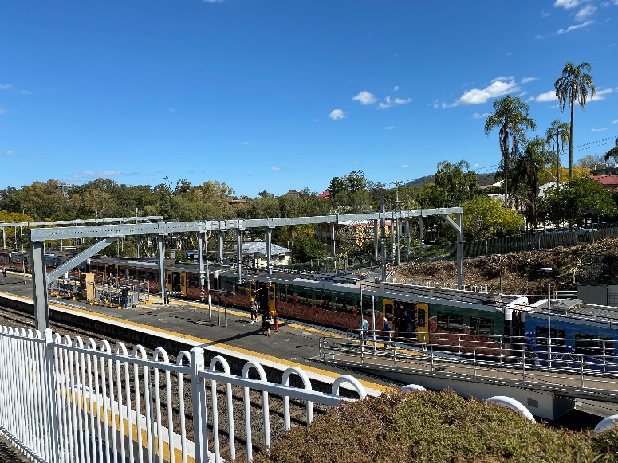 

# Construction impacts

# During works, construction activities may involve:

* changed parking and traffic conditions for safety
* noise associated with heavy machinery
* temporary changes to access paths throughout the station precinct and surrounding areas
* increased vehicle movements near works
* mobile lighting towers for night works.

# Normal working hours are 6.30am to 6.30pm, Monday to Saturday.

# The local community will be given advance notification of construction activities likely to cause impacts, including after hours work (nights, Sundays and public holidays, if required).

# Thank you for your patience and cooperation as we build you a better Auchenflower station.

# Contact us

# For more information, to provide feedback or to be added to the project’s opt-in distribution list for email updates:

# Phone: 1800 722 203 (free call)

# Email: stationsupgrade@qr.com.au

# Website: queenslandrail.com.au

# Novel Coronavirus (COVID-19)

# Queensland Rail is committed to keeping essential rail services operating for Queenslanders during this challenging time and to do this, network maintenance and critical works must continue. To support workforce safety, Queensland Rail has implemented a number of additional control measures related to COVID-19 management. We will continue to take the necessary precautions to ensure the ongoing health and wellbeing of our team and the communities in which we operate.