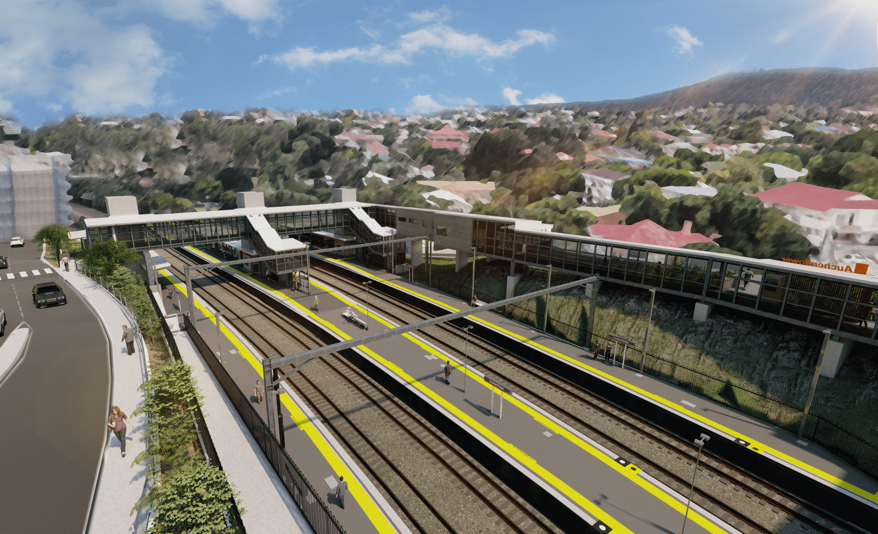
Auchenflower station accessibility upgrade

WORKS NOTICE

Wesley Hospital carpark access changes – Lang Parade closure
- 9pm Friday 3 to 5am Monday 6 June 2022
- Saturday 11 June 2022, 6am to 6pm
To construct the new pedestrian crossing as part of the Auchenflower station accessibility upgrade, Lang Parade will be closed (at the corner Chasely Street), from 9pm Friday 3 until 5am Monday 6 June and again on Saturday 11 June, 6am to 6pm. These works have been rescheduled due to recent adverse weather.
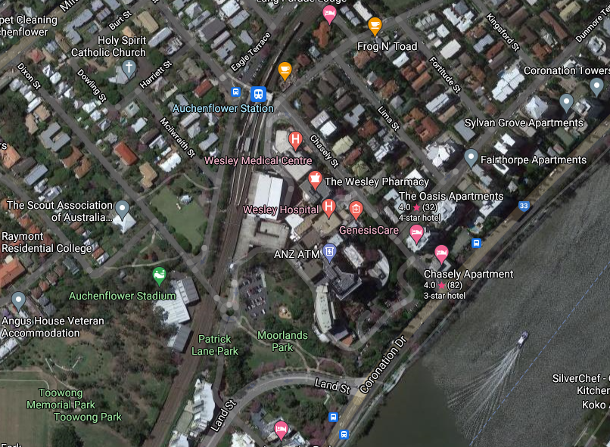
During these times all access to The Wesley Hospital public carpark will be via Patrick Lane (see map below). We apologise for any inconvenience as we undertake these important works.

Lang Parade closed

Access to The Wesley Hospital carpark
Auchenflower Tce
Lang Pde

Queensland Rail Limited ABN 71 132 181 090
Wesley Hospital carpark entry

Patrick Ln

Map data © Google, 2022
ROAD CLOSED

For more information, please contact the project’s community team on free call 1800 722 203 or email stationsupgrade@qr.com.au

