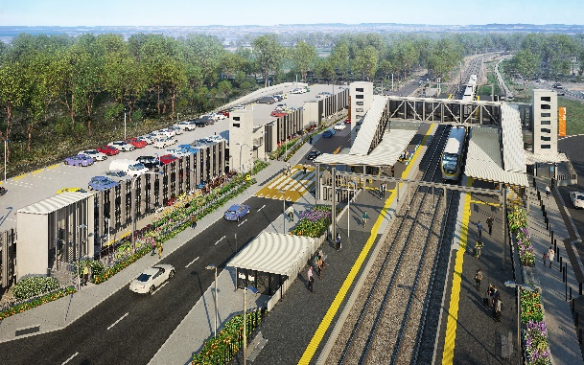
Dakabin station accessibility upgrade

WORKS NOTICE

After hours works – excavation and early morning concrete pours
April 2021

As part of the multi-storey carpark construction for Dakabin station accessibility upgrade, Queensland Rail is continuing to undertake a series of out-of-hours concrete pours on selected mornings in April 2021.
Platform excavation works are also scheduled over five nights from Monday 12 to Friday 16 April 2021, each night from 10pm to 6am the next day.
Note: These activities may be rescheduled, without further notice, due to weather or construction conditions.
Residents near the station may experience some noise associated with construction activity and truck movements. Mobile lighting towers will be used during night works. Every effort will be made to minimise disruption and inconvenience as we build you a better Dakabin station.

Overview of works
Queensland Rail Limited ABN 71 132 181 090
Location | Dates and hours of work | Type of work
Dakabin station precinct  Carpark work zone | Platform excavation works  10pm to 6am the next day on:  - Monday 12 to Friday 16 April  (over five nights)  Early morning concrete pours  From 2am on the following dates:  - Tuesday 13 April  - Saturday 17 April  - Wednesday 21 April  - Friday 23 April | Station upgrade works and carpark concrete pours involving:  - operation of trucks (including concrete trucks), excavators and machinery with flashing lights and reversing beepers  - operation of machinery including hand-held portable concrete vibrators  - movement of personnel and vehicles around the station precinct  - portable lighting towers at night.

The Dakabin station accessibility upgrade is part of the State Government’s ongoing investment of more than $500 million to upgrade stations across the South East Queensland network, making them accessible for all customers. For more information, please contact the project’s community team on free call 1800 722 203 or email stationsupgrade@qr.com.au

