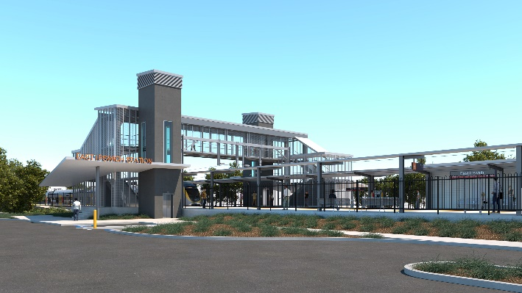
East Ipswich station accessibility upgrade

WORKS NOTICE

After hours works – overhead line and track works

May 2020

As part of the final preliminary works for the East Ipswich station accessibility upgrade, Queensland Rail will undertake after hours works in early May 2020 (weather and construction conditions permitting).
These works can only be undertaken when there is reduced rail traffic or the overhead power is switched off. For safety, traffic management will be in operation in Merton Street. Access to private properties will be maintained at the instruction of the traffic controller.
Nearby residents may notice noise associated with construction activities in the vicinity of the station precinct and adjacent rail corridor. Every effort will be made to minimise disruption and we apologise for any inconvenience as we work to improve your station.
Overview of after hours works
Location | Dates and hours of work | Type of work
East Ipswich station precinct (including carparks and rail corridor)  Rail corridor access gates:  - Merton Street, East Ipswich  - Irvine and Bunya Streets, East Ipswich | Night works:  6pm to 6am the next day on:  - Friday 1 May  - Wednesday 6 May  - Thursday 7 May  - Monday 11 May  Weekend works:  6am to 6pm the next day on:  - Saturday 9 May  - Sunday 10 May | Station accessibility preliminary works involving:  - operation of cranes, trucks and height access equipment with flashing lights and reversing beepers  - modification and installation of overhead line infrastructure  Queensland Rail Limited ABN 71 132 181 090  - on-track maintenance vehicles, including tamping machine, accessing the rail corridor  - operation of power tools and hand-held equipment  - movement of personnel and vehicles around the station precinct, rail corridor and access gates  - use of portable lighting towers at night  - traffic control (Merton Street).

Novel Coronavirus (COVID-19) – Queensland Rail is committed to keeping essential rail services operating for Queenslanders during this challenging time and to do this, network maintenance and critical capital works must continue. To support workforce safety, Queensland Rail has implemented a number of additional control measures related to COVID-19 management. We will continue to take the necessary precautions to ensure the ongoing health and wellbeing of our team and the communities in which we operate.
The East Ipswich station accessibility upgrade is part of the State Government’s $357 million investment to upgrade stations across the South East Queensland network, making them accessible for all customers.
For more information, please contact the project’s community team on free call 1800 722 203 or email stationsupgrade@qr.com.au

Sign up for paperless notifications at queenslandrail.com.au/EmailNotification

