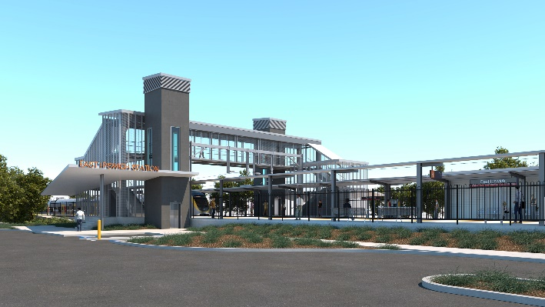
East Ipswich station accessibility upgrade

WORKS NOTICE

Night works – overhead line and signalling activities

Monday 2 March 2020

As part of ongoing preliminary works for the East Ipswich station accessibility upgrade, Queensland Rail will undertake night works on Monday 2 March, from 6pm until 6am the next day (weather and construction conditions permitting).
These works can only be undertaken at night when there is reduced rail traffic and overhead power is switched off.
Nearby residents may notice construction activities and associated noise in the rail corridor.
Every effort will be made to minimise disruption and inconvenience as we work to improve your station.
Overview of after hours works
Queensland Rail Limited ABN 71 132 181 090
Location | Dates and hours of work | Type of work
East Ipswich station precinct and rail corridor  Rail corridor access gates:  - Irvine and Bunya Streets, East Ipswich  - Coronation and Merton Streets, East Ipswich | 6pm to 6am the next day on:  - Monday 2 March  (overnight) | Station accessibility preliminary works involving:  - operation of lifting equipment including cranes, trucks and height access equipment with flashing lights and reversing beepers  - modification and installation of overhead line infrastructure  - signalling works and track testing  - on-track maintenance vehicles accessing the rail corridor  - operation of power tools and hand-held equipment  - movement of personnel and vehicles around the station precincts, rail corridor and access gates  - use of portable lighting towers.

The East Ipswich station accessibility upgrade is part of the State Government’s $357 million investment to upgrade stations across the South East Queensland network, making them accessible for all customers.
For more information, please contact the project’s community team on free call 1800 722 203 or email stationsupgrade@qr.com.au

We are moving towards paperless notifications about noise and works. You will still see paper notices as we transition to the new system. Sign up at queenslandrail.com.au/EmailNotification or contact us if you prefer to receive paper copies.

